Student Newsletter

Brought to you by EHD Student Affairs, Career Services, Diversity, Equity, and Inclusion, and the Library

In this issue...

Getting Connected
Announcements
Career
Office of Diversity, Equity, and Inclusion

Getting Connected

Ed Council Brain Break: Monday, May 1st
Join Ed Council at their spring semester brain break on Monday, May 1st, between 10am-2pm^{t}. There will be food and various activities in both the Ridley Lobby and Breneman Courtyard (in between Bavaro and Ridley Halls). Come and decompress before finals!

Announcements

CAPS Care Manager Workshop: Finding Mental Healthcare Providers in the Community
Join the Counseling and Psychological Services (CAPS) Care Managers for a “Finding Mental Health Care Providers in the Community” virtual workshop on Wednesday, May 10 at 1:00pm. The workshop will be held on Zoom. Register now!
- Whether you are a current or graduating student seeking care in your community (Charlottesville or anywhere in the U.S.), this workshop is for you!
- We’ll discuss insurance benefits and how to identify and connect with a provider who’s right for you.

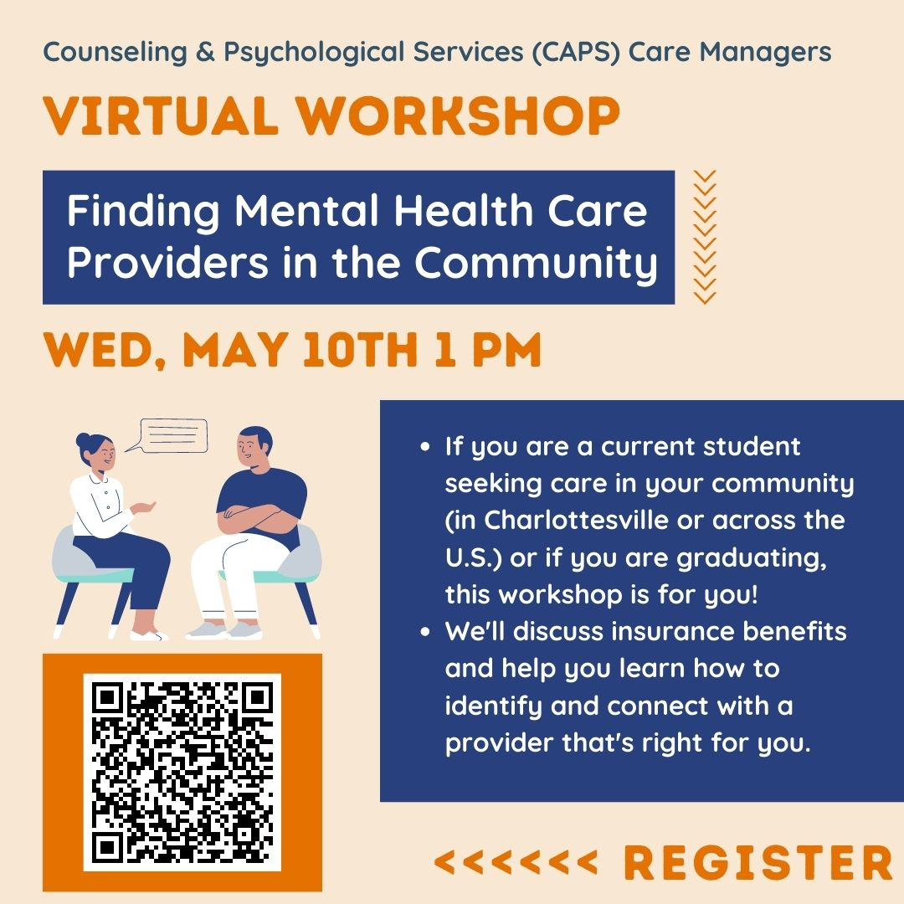

Join the 2024 Hunter Student Research Conference (HSRC) Planning Committee
As we plan ahead for the 2024 conference, we invite you to nominate yourself or a current student to join the HSRC planning committee. Volunteers join the team for one year; committee and conference chairs serve for two years with a co-chair. All undergraduate, graduate, online, and on-grounds students are welcome to join our team!
For more information about our committees, please access this explanation of committee responsibilities or email HSRC 2024 chair Anna Yonas. We look forward to receiving all nominations by May 1, 2023"nominate yourself or a current student. More information here!
Explanation of committee responsibilities - HSRC Committee Responsibilities.docx
Anna Yonas - amy9qr@virginia.edu

Finals Study Space Near Grounds!
Looking for a quiet study space for finals with free coffee, tea, snacks, fast Wi-Fi, and plenty of natural light? UKirk UVA is hosting finals study hours at Common Grounds* from Noon to 6 p.m. on weekdays from Thurs., May 4, through Wed., May 10. Dinner will be provided three nights (May 4, 5, and 8). Questions? Reach out to Dorothy Piatt-Esguerra (dpiatt@westminsterva.org).
*Common Grounds, located at 480 Rugby Rd., is the white building at the corner of Rugby Rd. and Gordon Ave., just down the block from Beta Bridge.

Summer 2023 Student Canvas Trainings
These sessions will introduce you to Canvas, and show you how to best utilize its features as a student of the School of Education and Human Development at UVA. Please sign up at least 24 hours in advance. All the sessions will cover the same information so there is no need to sign up for multiple sessions. Sign up here.
If you have any questions or concerns, including those regarding accessibility or accommodations, please email LDTI@virginia.edu.

Career

Job Opportunity: “Hoo2Hoo Peer Mentor"
The Learning Design and Teaching Innovation team is looking for a Hoo2Hoo Peer Mentor for our Hoo2Hoo Network. As a peer mentor you will gain experience in facilitating a variety of instructional workshops in collaboration with your peers. This program provides opportunities for student leadership as well as equip students with both the knowledge base and skill set to be competitive within their future careers and expand on their extracurricular interests.
This is a part-time position for UVA students, and it will run from July 2023-May 2024. Online, on-Grounds, undergraduate, and graduate students are welcome to apply!
Please submit your application by Friday, April 28th.
Apply here.
Full position description here.

Spring semester appointments for EHD one-on-one Career Assistance are available with your UVA-EHD Career Advisor, Hilary Kerner
Tuesdays 12-2pm virtual or Wednesdays 3-5pm either virtual or in-person) please select a 30-minute appointment slot here or otherwise email kerner@virginia.edu to request a time to meet between 12-4pm, M-Th. Either in-person or virtual appointments are available on Wednesdays and Thursdays.

Check the Career Corner in Canvas!
It’s never too late: The latest UVA EHD-centric job & internship opportunities from alumni, faculty and friends of UVA EHD (the career corner of Canvas Virtual Community) are here!

Attention International students: GoinGlobal announces new OPT feature in their platform
As a reminder, GoinGlobal (a subscription-based service that the UVA career offices jointly pay for) has always provided international students with a searchable database of employers who have filed H1B petitions for their employees in the past – and this list can give international students a good indication that those same employers might be open to hiring international students on OPT.
GoinGlobal just announced a new OPT feature in their platform. They’ve curated a list of the “top US employers with an established track record of hiring F1 students with OPT authorization.”
Students can access GoinGlobal for free through the resource card in Handshake.

Office of Diversity, Equity, and Inclusion

DEI Small Grant Applications
Grant Cycle opens on March 31st and closes on April 30th
The DEI Small Grant is a funding opportunity to support interdisciplinary school-level activities, events, or projects that have the potential to enhance diversity, promote equity, and foster inclusion across departments and centers and amongst students, faculty, and staff. The grant is open to all EHD faculty, staff, and students interested in leading an activity to foster diversity, equity, and inclusion within the School’s departments and centers. Collaboration is highly encouraged! To learn more about our DEI Small Grants, criteria for award, and application, click on the link below! If you have any questions, feel free to email ehdodei@virginia.edu.
More information here.

¡Vamos a celebrar! Juntos
¡Vamos a celebrar! Juntos is a reunion celebration of the UVA Hispanic and Latinx family. UVA alumni will have the opportunity to connect with current students, see what’s new on Grounds, and learn how to support and get involved with the UVA Hispanic/Latinx community. The schedule features a variety of events, including dancing and social events, networking opportunities, open houses, seminars, and more!
The Alumni Association is proud to partner with the Bolívar Network, the Juntos alumni committee, and partners across the University to present this inaugural event.
For more information, see the JUNTOS Alumni Weekend webpage.

2023 Inclusive Excellence Award
The Division for Diversity, Equity, and Inclusion is now accepting proposals for the 2023 Inclusive Excellence award making cycle. More information about the purpose of this program, the application process, selection criteria, and previously funded awards is available on the Inclusive Excellence Grants website. Access the application online. The application deadline is April 28, 2023.
Apply here!

