Student Newsletter

Brought to you by EHD Student Affairs, Career Services, Diversity, Equity, and Inclusion, and the Library

In this issue...

Getting Connected
Library
Career
Announcements
Office of Diversity, Equity, and Inclusion

Getting Connected

EHD Community Run with Jim, Stroll with Stephanie
Join UVA President Jim Ryan and EHD Dean Stephanie Rowley at the community “Run with Jim, Stroll with Stephanie” happening on Thursday, April 20th, at 7:30am in Breneman Courtyard (in between Bavaro and Ridley Halls). Light breakfast to follow, RSVP here!

Graduate Student Flower Arranging Workshop
Join other EHD graduate students Friday, May 5th from 11 AM - 1 PM in Holloway Hall for this special event. We will surround ourselves with flowers, ribbons, and tools, and get to creating one-of-a-kind, love-filled bouquets for our graduating friends and colleagues. Coffee and pastries and even some professional guidance will be provided!
This event is free and open to all EHD graduate students. RSVP here!

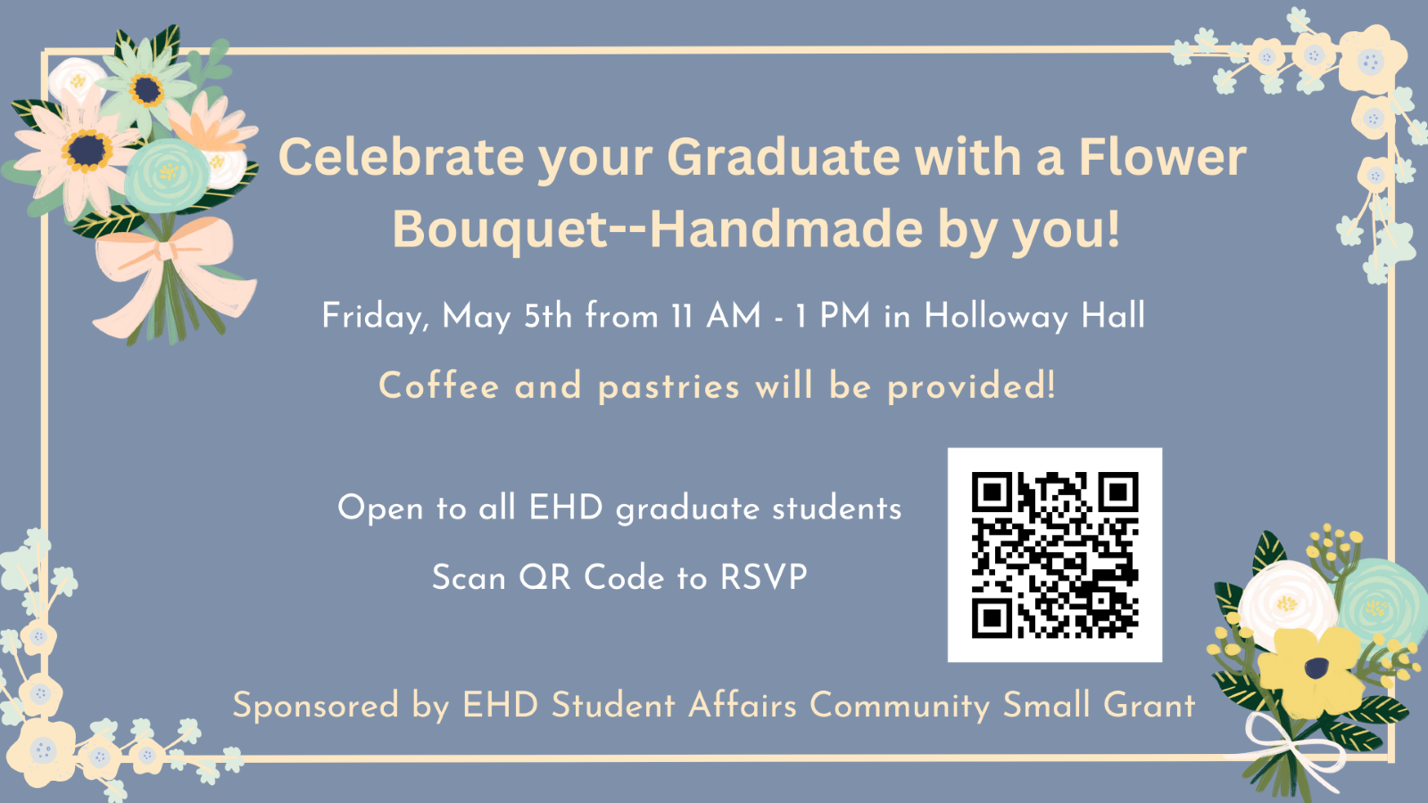
Be a part of EHD's Teacher Appreciation Week Content!
Record a short video thanking teachers to be a part of EHD’s teacher appreciation content!
Please record and submit videos by April 26.
Contact Christian Griffith for more information at wcu4nd@virginia.edu

Library

Thesis/Dissertation Deposits
Per graduation requirements, all schools require deposit of dissertations into the Library's ETD Repository, which we call “LibraETD”. We offer an ETD Checklist to walk students through what to expect during the deposit in LibraETD: click here.
Once a student defends their thesis/dissertation, a school or department administrator records that “milestone” in the student information system (SIS). The SIS system sends that information to LibraETD once a night and then Libra sends an email to the student informing them that they can now deposit. A student CANNOT log on to LibraETD and deposit until they get a confirmation email from Libra.
All questions and problems about depositing in LibraETD should go to the email address: libra@virginia.edu

Last Graduate Café of the Semester on April 26th!
Wednesday April 26th, 2-5pm
Brown Library 133 (Clark Hall)
Hang out with us for a working session dedicated to free coffee, snacks, and a great workspace exclusively for graduate students, postdocs, and faculty. It's like a coffee shop where you don't have to pay! The three hour block is a drop-in session, so come and go as you like. Librarians will be available on-site for research consultations and writing center consultants will be available for writing support to help you with your projects/assignments.
Held in partnership with the School of Education and Human Development's Student Affairs office and the UVA Writing Center. Register online- here

Career

Teaching Channel with Learners Edge Think Tank Workshop
Thursday, April 20th 2023
5:00 pm - 6:00 pm
Looking for an opportunity to showcase your teacher skills? Would you like to have ed tech content development experience on your resume or CV? Let’s team up to create some downloadable materials and enjoy collaboration with fellow educators! Join us for a THINK TANK workshop! 60 minutes 5pm Thursday, April 20 Your host: Wendy Amato is a fellow UVA alum (MEd ‘08, PhD ‘12) who serves as the Chief Academic Officer for Teaching Channel. Teaching Channel is an ed tech company that provides teachers, administrators, districts, and states with tools and resources that support instruction and learning. RSVP here!

Student Affairs Internship Grants here.
UVA Student Affairs Internship Grants (through our central UVA Career Center) can provide funding for students who are pursuing unpaid internships in public service. (These were formerly known as UVA Parents Fund Internship Grants). It’s a great opportunity for education students that may be doing unpaid internships with nonprofits, for example.
You can find details about the Student Affairs Internship Grants here. The deadline is today, Monday, April 10.
The student must have already secured their unpaid internship and it must fall into one of the following categories: Civic Engagement and Public Policy; Economic and Business Development; Education, both K-12 and Lifelong Learning; Environment, both planned and natural; Health; Sustainability.
If you have questions please contact: Michelle Ball at: mball@virginia.edu

Check Out the Career Corner in the Canvas Virtual Community!
Have you seen the latest UVA EHD-centric job & internship opportunities? They are continuing to roll in from alumni, faculty and friends of UVA EHD, especially at this time of year? Find them in the Career Corner of our Canvas Virtual Community here.

Announcements

Facilities Management Reminder
Facilities Management would like to remind staff, faculty and students to not flush paper towels down the commodes. Facilities Management has experienced a rash of plumbing issues across grounds to include Bavaro Hall. Please place used paper towels in the trash receptacles provided for you in the rest rooms.

Hoo2Hoo Network April Events Art Journaling Workshop
Looking for a way to creatively de-stress and relax during finals season? Look no further! Join the Hoo2Hoo network on Monday April 17th from 5-6pm for a FREE virtual workshop on how to create your very own art journal!
This workshop is open to those of all levels of knowledge but will be best suited to those who are beginners to art journaling. By the end of this workshop, attendees will be able to:
• Recognize the benefits of art journaling as a form of creative self-care
• Incorporate mindfulness and mediation into art journaling
• Creatively use art supplies and other materials they already own
• Utilize various creative and organizational techniques
Register here!

Final Exam Survival Workshop
Do you feel overwhelmed and stressed when it comes to final exams? Are you looking for ways to make it less challenging? Look no further than our Final Exam Survival Workshop! Our peer mentor will guide you through utilizing effective and research-based study methods, exemplifying time management skills, and implementing new stress coping strategies. You'll have the chance to create your own final exams survival toolkit through a ranking game. Thursday, April 20th, 5-6pm.
Don't let final exams bring you down – sign up here
Art journaling registration: click here
Finals survival registration: click here

Join the 2024 Hunter Student Research Conference (HSRC) Planning Committee
As we plan ahead for the 2024 conference, we invite you to nominate yourself or a current student to join the HSRC planning committee. Volunteers join the team for one year; committee and conference chairs serve for two years with a co-chair. All undergraduate, graduate, online, and on-grounds students are welcome to join our team!
For more information about our committees, please access this explanation of committee responsibilities or email HSRC 2024 chair Anna Yonas. We look forward to receiving all nominations by May 1, 2023

Movie Screening: Tukdam - Between Two Worlds
Attend the April 20 screening of the film "Tukdam: Between Worlds" to be shown at 7pm at Charlottesville's Violet Crown Cinema. Tickets are now on sale for the public and are included for registrants of the Contemplative Sciences Center's Generative Contemplation Symposium. Learn more at this link.

Generative Contemplation Symposium: The Art and Science of Effortless and Self-Emergence Contemplative Practices
Register for the Generative Contemplation Symposium: The Art and Science of Effortless and Self-Emergence Contemplative Practices being held April 20 and 21, 2023 at UVA. We will explore the tension between effort and effortlessness in contemplative practices within Indian and Tibetan Buddhism. Hosted by the Contemplative Sciences Center at UVA. The film Tukdam is included. Learn more at this link.

The Center For Race and Public Education In the South Spring Lecture - Esther H. Vassar
The University of Virginia School of Education and Human Development Center For Race and Public Education in the South will host a spring lecture featuring The Honorable Esther H. Vassar titled “From Teaching at Lane High School to Working in the Obama Administration: An Educator’s Journey”, on April 18 from 11:30 a.m. – 1pm. in Bavaro Hall 116, a small reception will follow immediately after the lecture in the atrium.

Ed Policy Speaker Series | Sarah Peko-Spicer | Researcher, American Institutes for Research
Come join us for the free, open to the public education policy research talk by Dr. Sarah Peko-Spicer. Dr. Peko-Spicer will be sharing her work on "Building a Critical Quantitative Practice" at 12:00 PM in Holloway Hall. More details on our website.

Friday Mindfulness Meetup with Student Health and Wellness
Every Friday | 10 AM - 11 AM
Student Health and Wellness, Multipurpose Room 101
Drop in to this student mindfulness group, facilitated by CAPS Director Dr. Nicole Ruzek! Offered every Friday, sessions begin with a brief introduction and include a mindfulness practice and debriefing. To register, email Nicole Ruzek (nar7r@virginia.edu).

Education Research Lectureship Series Hosts Hunter Gehlbach, Ph.D.
Hunter Gehlbach, Ph.D. is a Professor of Education, the Director of the PhD program, and a recovering Vice Dean at Johns Hopkins University, as well as the Senior Research Advisor of Research at Panorama Education. In this conversational talk, we will explore social perspective taking—the process of discerning the thoughts, feelings, and motivations of others—as a foundational building block of relationships and a promising focal point for interventions. Our aspirational goal is for everyone to leave the conversation with at least one new idea for how to improve social relationships in schools. More information here!

Ed Policy Speaker Series | Sarah Peko-Spicer | Researcher, American Institutes for Research (AIR)
Come join us for the free, open to the public education policy research talk by Dr. Sarah Peko-Spicer. Dr. Peko-Spicer will be sharing her work on "Building a Critical Quantitative Practice" at 12:00 PM April 24th in Holloway Hall. More details on our website!

Keeping our enemies closer: Political dialogue in a polarized democracy
April 25 from 9:30 to 11 a.m. in Holloway Hall (Bavaro 116)
Why would anyone object to respectful conversation among people who hold different political opinions? The reasons are many, as newspaper headlines and social media wars make clear. The fault lines of this debate became especially stark in Charlottesville, when far-Right groups staged a violent rally in August 2017. Donald Trump’s response that there were “very fine people on both sides” is now infamous for its apparent equivocation between self-proclaimed White supremacists and anti-racist activists.

This event features UVA School of Education and Human Development Associate Professor Rachel Wahl, with an introduction from Dean Stephanie Rowley. Wahl will focus on her empirical research examining what happens when people talk across political divides, when and how people thrive or struggle in these conversations, and what meaning, if any, these conversations hold for the effort to build a better democracy. More information and registration here!

Office of Diversity, Equity, and Inclusion

April 2023 DEI Collective Learning Series
The DEI Collective Learning Series continues in April with the topic of QuantCrit, or the application of critical race theory to quantitative methodology. On Week 4, Dr. Nicholas Bell (University of Delaware) will lead a presentation on Applying and Extending QuantCrit in Anti-Racist Research. To register for the session and to see the readings and videos for this month, please visit our Events page: Here
DEI Small Grant Applications: Grant Cycle opens on March 31st and closes on April 30th
The DEI Small Grant is a funding opportunity to support interdisciplinary school-level activities, events, or projects that have the potential to enhance diversity, promote equity, and foster inclusion across departments and centers and amongst students, faculty, and staff. The grant is open to all EHD faculty, staff, and students interested in leading an activity to foster diversity, equity, and inclusion within the School’s departments and centers. Collaboration is highly encouraged! To learn more about our DEI Small Grants, criteria for award, and application, click on the link below! If you have any questions, feel free to email ehdodei@virginia.edu.
DEI Small Grants Link

JUNTOS Alumni Weekend: A celebration of the Hispanic and Latinx community at the University of Virginia
April 14-15, 2023
¡Vamos a celebrar! Juntos is a reunion celebration of the UVA Hispanic and Latinx family. UVA alumni will have the opportunity to connect with current students, see what’s new on Grounds, and learn how to support and get involved with the UVA Hispanic/Latinx community. The schedule features a variety of events, including dancing and social events, networking opportunities, open houses, seminars, and more!
The Alumni Association is proud to partner with the Bolívar Network, the Juntos alumni committee, and partners across the University to present this inaugural event.
For more information, see the JUNTOS Alumni Weekend webpage.

UVA Acts workshops
Drawing on practices in Theatre of the Oppressed, Theatre in Education, and community-based performance, UVA Acts ensembles perform plays interrupted with moments of facilitated dialogue and audience intervention. Our programming is developed with a focus on interventions that faculty members can employ to promote equity in the workplace and the classroom. UVA Acts has several upcoming performances/workshops in April that are open to the UVA community.
See the UVA Acts webpage for more information and to register.

UVA Division for Diversity, Equity, and Inclusion April Events
UVA’s Division for Diversity, Equity, and Inclusion will offer several online workshops on a variety of DEIA topics, including implicit bias, introduction to DEI, microaggressions, equity, and dialogue. These workshops are open to the UVA community.
See the DDEI Events webpage for more details and to register.

Interfaith Student Center Ramadan Hours
The Interfaith Student Center will have the following adjusted operational hours starting the night of Wednesday, March 22nd, 2023 until the end of Ramadan on April 21st, 2023:
Monday to Friday: 10 AM to 11 PM
Saturday & Sunday: 12 PM to 11 PM
If you have any questions, please reach out to Alex Winkowski, Assistant Director - Multicultural Student Services, at alexw@virginia.edu.

On Friday, April 21, from 11:30-1:30 (or until we run out)
Interns from the Women’s Center will be tabling on South Lawn in honor of the 100th Reunion year of Dr. Lois Ketcham Carwile (first woman to graduate from the college in 1923 [BS in Math] and the first woman triple ‘Hoo [MS 24, PhD 27, both in Physics]) and the 70th Reunion year of Dr. Louise Stokes Hunter (first Black woman to graduate from UVA with a doctorate from the Education School. Learn more here!

On Monday, April 24, from 7-9 pm: (History of Women at UVA) Trivia Night, in the MSC with dinner from Pearl Island. Learn more here!

