Student Newsletter

Brought to you by EHD Student Affairs, Career Services, Diversity, Equity, and Inclusion, and the Library

In this issue...

Announcements

Career

Office of Diversity, Equity, and Inclusion

Getting Connected

Library

Announcements

Lasting Legacy Nominations
Are you a graduating student who wants to nominate a faculty or staff member for making a positive impact during your time at EHD? Click the link here!

Finding Mental Healthcare Providers in the Community
Join the Counseling & Psychological Services (CAPS) Care Managers for a “Finding Mental Health Care Providers in the Community” workshop on Friday, March 31 at 1:00pm. The workshop will be held in the Student Health and Wellness Building (550 Brandon Ave) in the Multi-Purpose Room (first floor, directly to the right of the main front entrance.) Visitor parking is available!
· If you are a current student seeking care in your community (in Charlottesville or across the U.S.) or if you are graduating, this workshop is for you!
· We’ll discuss insurance benefits and help students learn how to identify and connect with a provider who’s right for them.
· Free cookies and swag giveaways!
Please email capscaremanagers@virginia.edu with any questions.

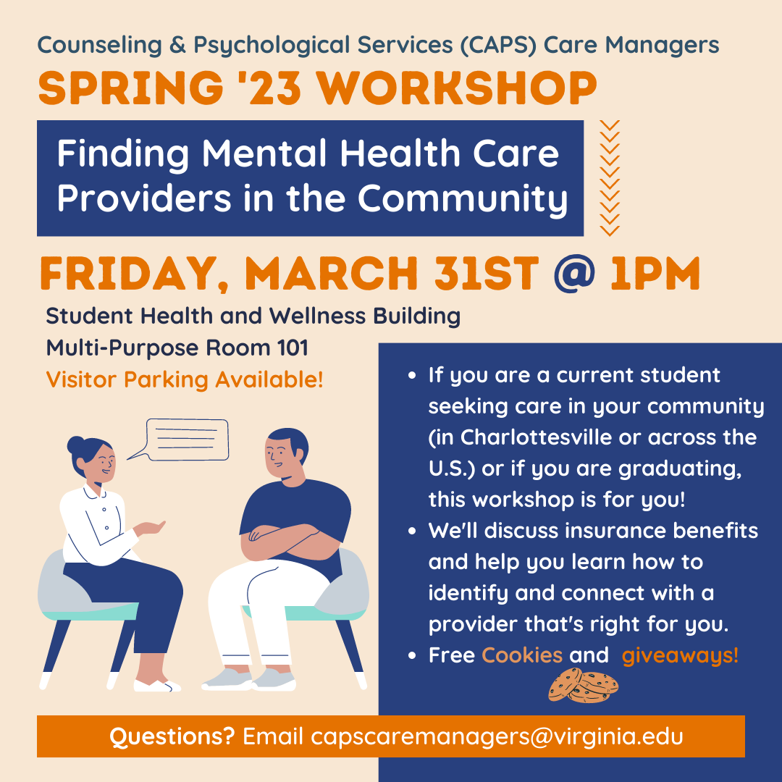

Yuria Celidwen - The Ethics of Belonging of Indigenous Contemplative Traditions
Attend the talk "The Ethics of Belonging of Indigenous Contemplative Traditions" by Yuria Celidwen on March 31, 3:00-5:00pm. Holloway Hall, Bavaro Hall (116). Celidwen, an Indigenous Nahua and Maya scholar from Mexico, will speak about how Indigenous traditions hold critical solutions to help meet pressing social and environmental injustices through deep cultural roots of contemplative wisdom. Learn more here!

Fridays at Batten: Celebrating Women's History Month: A Conversation with Shelley Brindle, Mayor of Westfield, NJ
Join Shelley Brindle, Mayor of Westfield, NJ and Batten's Women in Policy for a discussion on Mayor Brindle's role in public office. Mayor Brindle has drawn upon her role as the first woman in HBO's C-suite to serve as a mentor to emerging female leaders and entrepreneurs, as well as apply her leadership and operating skills to serve as Mayor of her hometown. RSVP here!

Generative Contemplation Symposium: The Art and Science of Effortless and Self-Emergence Contemplative Practices
The Contemplative Sciences Center is hosting the Generative Contemplation Symposium: The Art and Science of Effortless and Self-Emergence Contemplative Practices on April 20 and 21, 2023 at UVA. This in-person event will convene scientists, scholars, philosophers, and teacher-practitioners from across the world to explore the tension between effort and effortlessness in contemplative practices within Indian and Tibetan Buddhism. Learn more here!

Career

Spring Semester 30-minute EHD Career Assistance Available!
Spring semester appointments for EHD one-on-one Career Assistance are available with your UVA-EHD Career Advisor, Hilary Kerner. Please select a 30-minute appointment slot here (or otherwise email kerner@virginia.edu to request a time to meet between 12-4pm, M-Th).

Need to Fund your Great Summer Internship find?
Have you found a great internship that is not paid, and need funding? Try applying for a UVA “Student Affairs Internship Grant.” To do so, you would need to complete the funding application here (once you identify the internship).

Become a Hoos Connected Facilitator! Apply by March 31st
Hoos Connected brings together small groups of new students to have discussions led by 2 trained facilitators (1 of which could be YOU) about what brings us together, keeps us apart, and how these things manifest at UVA. To apply, email hoosconnecteduva@gmail.com with your resume, unofficial transcript, and a short paragraph about why you would like to be considered. The application deadline is Friday, March 31st.

Urban Ed Leaders Internship Program w/ DC Public Schools
The Urban Education Leaders Internship Program (UELIP) provides individuals the opportunity to get firsthand experience working in the Central Office of DCPS, one of the most innovative school districts in the U.S. and the fastest growing urban district in the nation. Associates are matched with a team of professionals in Central Office to participate in mission-critical projects and participate in professional development including mentorship and coaching from district leaders, develop skills, network, and complete a final Capstone project, gaining hands-on experience to create positive change. There is no major study requirement, so this opportunity is open to all UVA current students and alumni. If you are interested in being an UELIP Associate this summer, please apply here! . You can find the recruitment flyer here.
For questions, please email the program team at UELIP@k12.dc.gov

GoinGlobal announces new OPT feature to their platform!
Attention International students: As a reminder/introduction, GoinGlobal (a subscription-based service that the UVA career offices jointly pay for) has always provided international students with a searchable database of employers who have filed H1B petitions for their employees in the past – and this list can give international students a good indication that those same employers might be open to hiring international students on OPT. They’ve curated a list of the “top US employers with an established track record of hiring F1 students with OPT authorization”. Students can access GoinGlobal for free through the resource card in Handshake.

UVA-Centric Job and Internship Opportunities
The latest UVA EHD-centric job & internship opportunities from alumni, faculty and friends of UVA EHD (in the career corner of Canvas Virtual Community) are here!

Education Coordinator for Cancer Research, Training, and Education Core (CRTEC) The UVA Comprehensive Cancer Center
(UVACCC) seeks a program coordinator to facilitate and support education, training, and mentorship activities. This position will provide assistance to the Associate Director for CRTEC to achieve the education mission of the center. This position is critical to UVACCC’s National Cancer Institute designation. Click here to learn more and apply.

Office of Diversity, Equity, and Inclusion

Interfaith Student Center Ramadan Hours
The Interfaith Student Center will have the following adjusted operational hours starting the night of Wednesday, March 22nd, 2023 until the end of Ramadan on April 21st, 2023:
Monday to Friday: 10 AM to 11 PM
Saturday & Sunday: 12 PM to 11 PM
If you have any questions, please reach out to Alex Winkowski, Assistant Director - Multicultural Student Services, at alexw@virginia.edu.

EHD Iftar Meal
The School of Education and Human Development is holding an Iftar meal on Wednesday, April 12 in Holloway Hall (Bavaro Hall 116). Doors open at 7:30pm. RSVP here!

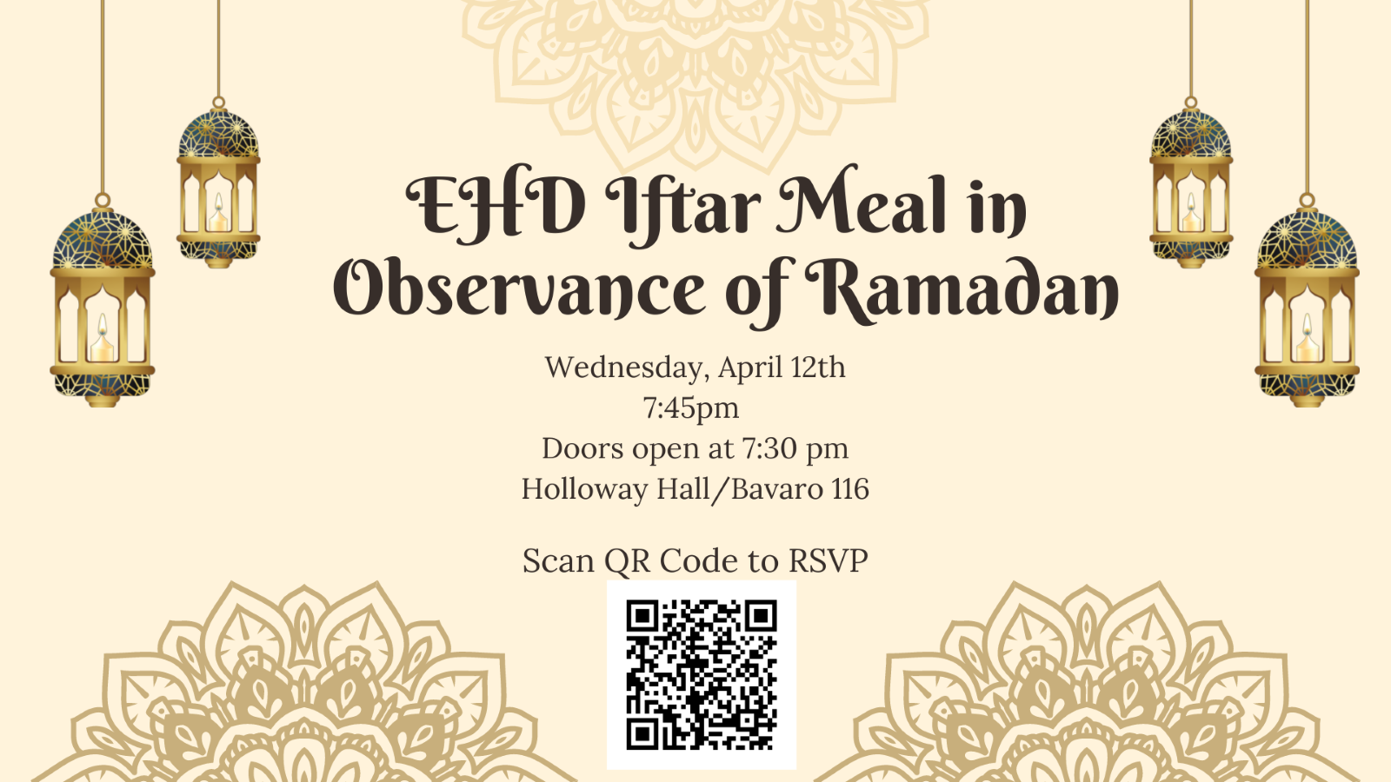

Meghan Buell, UVA Visit 3/30
Meghan Buell is the Founding Director of TREES, Inc. (the Transgender Resource, Education and Enrichment Services), an educational organization created to enrich the lives of transgender identifying people who reside in under-served communities. She has been a leader in the transgender community locally, regionally and nationally and has served on nonprofit boards, transgender advisory committees and is a regular collegiate guest lecturer. More information and RSVP here!

Black Scholars Writing Group All Grounds Writing Retreat
Date: Wednesday, April 5th, 12-3pm
Registration Deadline: March 30th Location: Bavaro 116 (Lunch Provided) During this event, participants will build community and advance their academic writing while meeting Black graduate students from across UVA. Dean Stephanie Rowley will provide remarks. Register here!

The Annual African Studies Colloquium: “Marcus Garvey was the father of Pan-Africanism”
3/30/2023 Time: 3:30 pm - 5:00 pm Location: 110 Minor Hall
This lecture is one of several in the African Studies Colloquium, an annual event hosted by the Carter G. Woodson Institute and the African American and African Studies Department at the University of Virginia. On March 30th, Dr. Erik McDuffie, Professor of History and African American Studies, University of Illinois Urbana Champaign, will give the talk "Marcus Garvey was the father of Pan-Africanism."
For more information, contact: kvg6ge@virginia.edu

UVA Division of Diversity, Equity, and Inclusion Presents: Ellington's Evening of Music & Poetry featuring Stokley
Ellington’s Evening of Music and Poetry (April 8) is a night to celebrate the arts through spoken word poetry, R&B, and soul music. The event will feature Grammy-nominated vocalist, songwriter, producer, and multi-instrumentalist, Stokley. Stokley is a GRAMMY-nominated vocalist, songwriter, producer, and multi-instrumentalist who is one of music’s best-kept secrets. Reserve free tickets here!
EHD DEI Small Grant Applications
The DEI Small Grant is a funding opportunity to support interdisciplinary school-level activities, events, or projects that have the potential to enhance diversity, promote equity, and foster inclusion across departments and centers and amongst students, faculty, and staff. The grant is open to all EHD faculty, staff, and students interested in leading an activity to foster diversity, equity, and inclusion within the School’s departments and centers. Collaboration is highly encouraged! If you have any questions, feel free to email ehdodei@virginia.edu. Here is the grant application (it opens Friday, 3/31), and here are directions for submitting the grant.
Common Read 2023-2024 Book Nomination
Please nominate books you think should be considered for the 2023-2024 EHD Common Read. In addition to asking for the name and author(s), we will ask you to tell us why you think the book would be a good choice for the Common Read and include links to reviews, etc. We also appreciate suggestions for potential speakers and/or topics for the Beyond the Common Read series to show the breadth of how the community can engage with the book (there is space in the form to provide this info). Nominate here!

UVA Office of Diversity, Equity, and Inclusion Events
That’s The Way of the World: More Information and RSVP here!
Free Your Mind: Intro to Implicit Bias: More Information and RSVP here!
I Felt That: Microaggressions and Impact: More Information and RSVP here!

UVA Acts Events
You Can Call Me: More Information and RSVP here!
Leading Small Teams: More Information and RSVP here!

Getting Connected

Evening of Self-Care
Please join EHD's Lysandra Cook for an evening of self-care.
Thursday, March 30th, 7:00PM EST
No registration required: Zoom link here.

Undergraduate Social: April 4, 10am-12pm
Are you an undergraduate student in need of study time? Drop in to our social to study and grab snacks! April 4, 10am-12pm in Holloway Hall (Bavaro 116). RSVP here!

Ed Council Terrarium Event
Join Ed Council on April 6th at a Make Your Own Terrarium Event! The event will be on 4/6 in Holloway Hall (Bavaro 116), from 1-2:30pm, with food served. RSVP here!

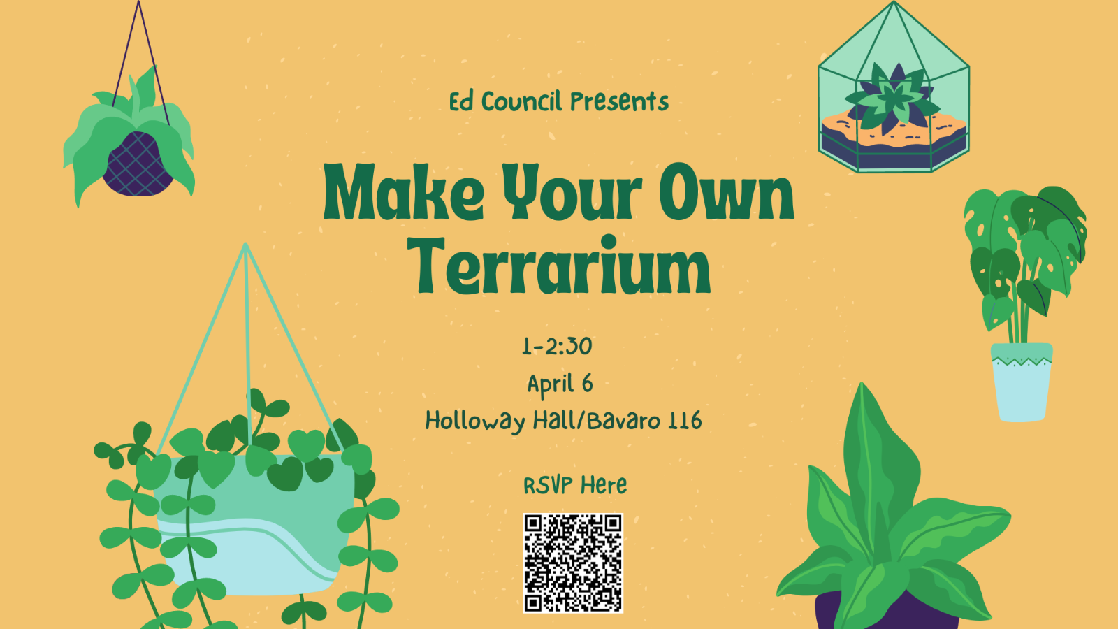

Library
EHD LibGuide: Black History in Education and Human Development

This guide is developed by the University of Virginia Library in partnership with the School of Education and Human Development’s Office for Diversity, Equity, and Inclusion (ODEI). It is designed to support inquiry and curriculum on Black History for the School of Education and Human Development year-round and provides resources on the history, influence, and legacies of Black educators and historical actors on our education system, on our history, and on the University of Virginia. Check it out here!

