Student Newsletter

Brought to you by EHD Student Affairs, Career Services, Diversity, Equity, and Inclusion, and the Library

In this issue...

Office of Diversity, Equity, and Inclusion

Career

Announcements

Getting Connected

Library

Office of Diversity, Equity, and Inclusion

Latinx Student Handbook
The Latinx Handbook was created by Latinx students here at UVA; it provides resources for students, as well as strengthening the Latinx student community. Check it out here!

Conversations About Race and Equity
We are very excited to extend an invitation to participate in a discussion group called C.A.R.E. (Conversations about Race and Equity) with other School of Education students. Broadly, the goal of C.A.R.E. is to facilitate an opportunity for students to have meaningful conversations about diversity, race, and social justice. Due to its continued success and the intensified need for discussions and movement around social justice issues in our academic community and beyond, we’re pleased to offer the C.A.R.E. group in a virtual and in-person format for the Spring 2023 semester. Please sign up on or before March 20th to be considered for participation in a group.
Sign Up Link Here!

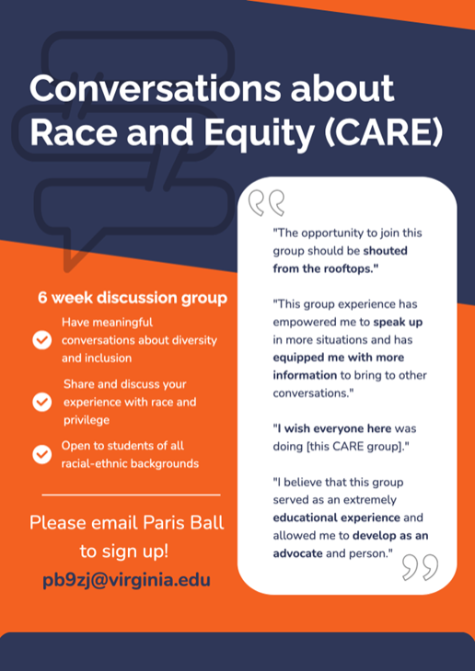

QVA Scholarships Available!
Nearly $100,000 in scholarships are available this semester from QVA, UVA’s LGBTQ+ Alumni organization (formerly known as the Serpentine Society)! Applications are due by Friday March 17th, at 11:59 P.M.
• QVA Grants are open to highly motivated LGBTQ+ students with financial need. Dozens of grants are available and amounts range from ~$500 to ~$5,000.
• The Jeffrey L. Reider and Charles F. Otis Endowed Prize focuses on students of any sexual orientation who have demonstrated a willingness to advance the rights and acceptance of the LGBTQ community. Activity in music and the arts will also be considered. Two or three scholarships up to $5,000 each will be awarded.
• The John A. Herring Scholarship for Social Awareness focuses on leadership, citizenship, and fellowship for students who have actively supported, through volunteerism and advocacy, the LGBTQ Center at the University of Virginia. Two $5,000 scholarships will be awarded. Students must be nominated by someone for the Herring award vs. applying on their own.
Students may apply for multiple of these awards, though they are encouraged to pick the one(s) which best match their needs and experiences. Please notify felix@queervirginia.org and blake@queervirginia.org with any questions.

Diversity Action Committee Seeking Nominations for 2023-2024 Common Read
Please nominate books you think should be considered for the 2023-2024 EHD Common Read. In addition to asking for the name and author(s), we will ask you to tell us why you think the book would be a good choice for the Common Read and include links to reviews, etc. We also appreciate suggestions for potential speakers and/or topics for the Beyond the Common Read series to show the breadth of how the community can engage with the book (there is space in the form to provide this info). Nominate books here!

Career

Hoo2Hoo Network: Student LinkedIn Workshop
Are you looking to enhance your professional presence on LinkedIn? Our Hoo2Hoo peer mentor will provide you with actionable tips and tricks to make your profile stand out and attract potential employers and professionals. This workshop is perfect for anyone who has limited experience using LinkedIn and would like to learn more about how to navigate the platform. Join us for a workshop that will teach you how to: • Create your personal LinkedIn headline • Advance your homepage • Enhance your professional presence on LinkedIn • Expand your network and connection March 20th 5pm-6pm, on Zoom. Don't miss out on this opportunity to learn from the best and become a LinkedIn pro! Please register from this link

Student Research Assistant Position Available for Spring and Summer 2023!
Dr. Jonee Wilson in CISE is currently seeking multiple undergraduate and/or master’s level students to work as research assistants on a project called VEAR-MI in Spring and Summer 2023. In this project, students will have the opportunity to rate mathematics instruction videos with EAR-MI, a rubric that was developed to capture practices aimed to support marginalized students in gaining access and more equitably participating in rigorous math activity in elementary and middle-school classrooms. Students will be paid an hourly rate ($15/hour for undergraduate students; $21/hour for master’s students). Interested students can apply via the job posting (R0044739) linked here: Feel free to reach out to Jasmine Truong, VEAR-MI Project Coordinator, at jmtruong@virginia.edu with any questions!

Announcements

Re-Scaling Ethnic-Racial Identity, Youth-Nex Works-in-Progress Meeting
Dr. Channing Mathews, an assistant professor of psychology, is sharing some work under development entitled "Re-Scaling Ethnic-Racial Identity: Do current measures accurately capture adolescents' and emerging adults beliefs in 2023?" during the TH 3/16 Youth-Nex Works-in-Progress meeting. This is a hybrid event with free Roots lunch in Ridley 206 starting at 12:30 PM ET, or join via Zoom. Email Youth-Nex@virginia.edu with questions. More information here.

Workshop Discussion with Professor Jon Zimmerman
Is Democratic Education Possible? Reflections on the Culture Wars, Past and Present Thursday, March 16 at 4pm, Bond House at Uva Link to register/learn more here. Americans have always argued over their public schools. But for most of our history, these conflicts focused on questions of religion and faith. Now we’re arguing about our conceptions of America, which have become quasi-religious beliefs in their own right. The big question is whether we can present diverse views of America in our public schools, rather than teaching a single story about it. Hear more from author, Jonathan Zimmerman, a Professor of History of Education and the Berkowitz Professor in Education at the University of Pennsylvania, former Peace Corps volunteer and high school teacher.

Fridays at Batten: Discussion with April Rinne and Batten Dean Ian Solomon
Friday, March 17th from 11:30am - 12:30pm in the Great Hall of Garrett, Batten will be hosting award-winning author, April Rinne for a discussion with Dean Solomon, Dean of the Frank Batten School of Leadership & Public Policy. April and Dean Solomon will discuss navigating a world that is constantly changing. As some of you are experiencing changes in your life (graduation, internships, jobs, etc.) I encourage you to attend this event and learn more about these best practices.
All who register and attend will be provided with FREE lunch.
Register here!

Aftershock Movie Screening & Panel
The University of Virginia School of Medicine's Office of Diversity, Equity, and Inclusion, Health Sciences Library, and University Physician's Group are hosting a screening of Aftershock, a documentary on Black maternal mortality and the Birth Justice Movement on Wednesday, March 22 at 6:00 pm eastern time (dinner at 5:30 pm).
The screening will be followed up with a panel of members from both the Charlottesville and UVA communities who are working to improve outcomes for BIPOC mothers and their families on Wednesday, March 29 at 6:00 pm eastern time (dinner at 5:30 pm). Register here!

Blue Ridge LEND Virtual Lunch & Learn Series
Join us virtually on Friday, March 31 from 12-1 pm as Bill Therrien and Gail Lovette present on The Flint Water Crisis: What happened and what can we do better in the future? After working on the legal case for almost four years, these two professors contributed to the outcome of $9 million in new funding for special education programs in Flint Community Schools. They will share their experiences and thoughts about ways to address future crises with interdisciplinary collaboration.
Registration link here
Click here for a Related News Article

UVA Voice Center’s 7th Annual World Voice Day Concert
April 28, 6-9 at Potter’s Craft Cider
A free outreach event for the public
Featured performer Toni Clare & other special guests

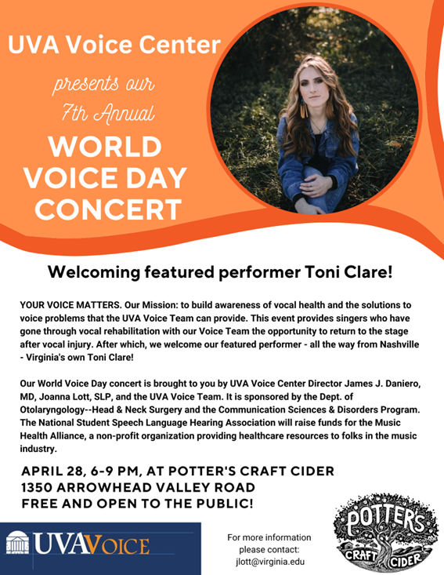

Getting Connected

EHD Community Breakfast
The EHD Community is invited to our upcoming breakfast with the Deans on Wednesday, March 29th, from 9-10:30am in Holloway Hall/Bavaro 116. RSVP here!

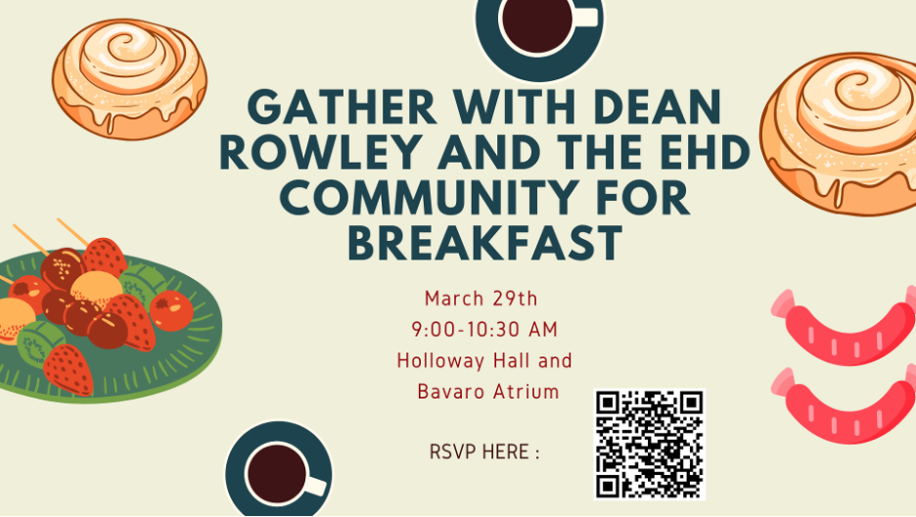

Circle of Support Event
Join the EHD Offices of Diversity, Equity and Inclusion and Student Affairs as we begin the conversation around our circle of supports and how various people in our lives play an important role in our own academic and professional journey. The event will be on Tuesday, March 28th, from 10-11:30am. Lunch will be served at the conclusion of the event. RSVP here!

Save the Dates: Upcoming Events
EHD Undergraduate Social: 4/4/23, 10-12am in Holloway Hall
Ed Council Event: 4/6/23, 1-2:30pm in Holloway Hall
EHD First-Generation Luncheon for Students, Faculty, and Staff: 4/12, 12:30-1:30pm in Holloway Hall
EHD Iftar Meal: 4/12/23 6:45pm in Holloway Hall
Graduate Support Event: 4/24/23, 12-2pm in Ridley 203

Library

Graduate Writing Cafes
Join EHD Librarian Ashley Hosbach at graduate writing cafes! More information, along with the RSVP, can be found here.

