Student Newsletter

Brought to you by EHD Student Affairs, Career Services, Diversity, Equity, and Inclusion, and the Library

Our thoughts are with the Michigan State University campus community during this difficult time.

In this issue...

Announcements

Career

Office of Diversity, Equity, and Inclusion

Getting Connected

Library

Announcements

NORD Students for Rare at UVA - 5K on 4/16
NORD Students for Rare at UVA will be hosting a 5k fundraiser on April 16, 2023! The Race for Rare will begin at 9 a.m. (with packet pick-up starting at 8 a.m.) in front of Old Cabell Hall at UVA’s South Lawn. Participants will run on a designated course through UVA’s Grounds and surrounding neighborhoods, and all proceeds from this event will go to the National Organization for Rare Disorders to directly benefit rare disease patients. Race sign-ups are now open, with additional options to participate virtually or donate to the cause if you can’t make it in person. We really appreciate your support and hope to see you on April 16th! Please email nordatuva@gmail.com with any questions.
Join us and Race for Rare!
Register and/or donate here

Augmented Reality Ap
Using an Augmented Reality App to Build Arrangements with Blocks (Blox) – Dyad Study You and your friend are invited to participate in an Augmented Reality game: using an Augmented Reality App to Build Arrangements with Blocks (Blox). This study involves arranging digital blox in a room with augmented reality through your smartphone and subsequently answering a series of questions about the experience in a questionnaire. Interested? Sign-up NOW with a FRIEND [http://:%20https/darden.sona-systems.com]here. Duration: approx. 40 min. Compensation: $10 dollars pay and a chance to win a $35 Amazon eGift card. Ages 18-24. Recruits must be college students with a snapchat account.

Cooper Lecture
Wed. March 15th Cooper Lecture: Erica Lembke "Erica Lembke, Professor in the Department of Special Education at University of Missouri, will present a Cooper Lecture on Wed. March 15th in Holloway Hall from 11:00 am to 12:15 pm. The title is "Data Based Instruction Across the Content Areas: Early Writing and Middle School Mathematics."
This lecture is sponsored by the Cooper Speaker Series and it is open to all UVA faculty, postdoctoral researchers, students, and staff. You do not need to RSVP in order to attend.
If you have questions, please contact Peter Youngs at pay2n@virginia.edu.

YEMSA Fundraiser
YEMSA Fundraiser for the UVA Breastfeeding Medicine Clinic. UVA's Youth Education and Maternal Support Association is currently holding a fundraiser for the UVA Breastfeeding Medicine Clinic, which will end on February 20th. By donating money to YEMSA@UVA through our Venmo, you will be helping us to purchase much needed products like breast pumps, breast pump cushions, pumping bras for NICU mothers, and bottles for the clinic. You can Venmo us at YEMSAatUVA. Also, be on the lookout for us on The Corner this Friday, February 10th, from 8-11pm where we will be selling baked goods to raise funds, as well! YEMSA Venmo: YEMSAatUVA

Antifascist Strategies for Schools & Communities, Youth-Nex Talk
Youth-Nex welcomes external affiliate Dr. Mimi Arbeit from Suffolk University for an in-person talk on Friday, February 24th at 11 AM in Bavaro Hall, Holloway Hall (Rm. 116) about “’We keep us safe’: Antifascist strategies for schools and communities.” Grad students can RSVP to Youth-Nex@virginia.edu to join a small group discussion after the talk.

Dean Rowley featured on President Ryan's Podcast!
Learn what keeps our dean up at night in episode 4 of this season's 'Inside UVA.'

Yoga for Climbing
March 16-April 20, 2023, 5-6pm
Join Geologist and Certified Ashtanga Yoga Teacher John Bultman for an exploration of yoga techniques that support rock-climbing! In this Thursday evening class you'll also gain insight on ways to create a consistent yoga practice. Don't miss this small group training opportunity offered in partnership with UVA's IM-Rec Sports.

Contemplative Institute for Teaching and Learning 2023: Regenerative Practice for Earth, Soul, and Syllabus
Apply now for the 2023 Summer Institute for Teaching and Learning: Regenerative Practice for Earth, Soul, and Syllabus. The event is taking place June 5 - 9, 2023 at the Sevenoaks Retreat Center, in Madison Virginia. Learn more and apply.

Hoo2Hoo Network: Student Canva Workshop
Want to learn how to use Canva to make your lesson plans, class presentations, or party invitations pop? Join the Hoo2Hoo Network Peer Mentors for a virtual workshop all about using Canva! Open to all EHD students. Monday, February 20th, 5pm-6pm, Zoom. Register here.

Career

Sign up for the Virtual Ed Expo on 2/15!
Details are here: https://app.joinhandshake.com/career_fairs/37415/student_preview
You will be able to sign up for group or individual sessions to talk to any of the following education organizations during the 3-6pm time frame!

Fulbright Information
Fulbright Forum – February 23rd at 5pm – For full details and to register click here.
This is our kick-off event for the Fulbright process. We are welcoming back four past UVA Fulbright recipients for a panel discussion and reception. The Fulbright funds further study, research, teaching, or creative opportunities abroad after graduation.

Paid Research Opportunity with Indigenous Youth & Communities
Youth-Nex professor, Dr. Lora Henderson Smith, is hiring for multiple graduate and undergrad students for a new research study with opportunities to gain experience with indigenous youth and in indigenous communities. These are hybrid and remote positions for the spring with the possibility to extend into the summer and maybe fall. For more info and to apply, please email Youth-Nex@virginia.edu!

Office of Diversity, Equity, and Inclusion

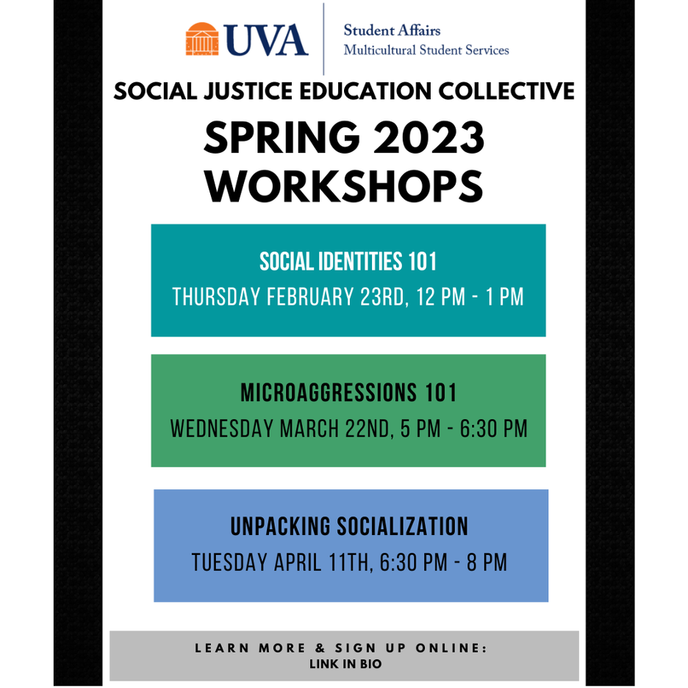

Social Justice Education Collective (SJEC) Workshops
Register for our upcoming workshops HERE
The SJEC Program aims to create multicultural educational opportunities and promote social awareness through workshops incorporating student experiences and academic literature of social justice education. Open workshops occur in the Multicultural Student Center (2nd Floor Newcomb Hall) and are open to all students to register & attend.
EHD Events
Beyond the Common Read - Life Isn't Binary: On Being Both, Beyond, and In-Between: Wednesday, February 22, 2023, 11:00am – 12:00am, Online & Holloway Hall (Bavaro Hall 116)
Please join Out and Allied Educators and the Office of Diversity, Equity, and Inclusion for Beyond the Common Read: Gender, Sexuality, and Mental Health with Dr. Alex Iantaffi, the author of this year's Common Read, Life Isn't Binary: On Being Both, Beyond, and In-Between. For registration, see here.

The Walter N. Ridley Distinguished Annual Lecture: Thursday, March 2, 2023, 3:30 pm – 6:00 pm, Alumni Hall
This year’s Walter N. Ridley Distinguished Annual Lecture by Dr. Bettina L. Love (Teacher’s College, Columbia University) is titled, “We Gon’ Be Alright, But That Ain’t Alright: Abolitionist Teaching and the Pursuit of Educational Freedom.” Dr. Love will discuss the struggles and the possibilities of committing ourselves to an abolitionist goal of educational freedom, as opposed to reform, and moving beyond what she calls the educational survival complex. Abolitionist Teaching is built on the creativity, imagination, boldness, ingenuity, and rebellious spirit and methods of abolitionists to demand and fight for an educational system where all students are thriving, not simply surviving. Read more about Dr. Love's work here

Register here

Events Website

ODEI Newsletter:
Black History Events Across UVA, Charlottesville, and Beyond
"Black Women in Jazz: Equitable Spaces & Empowerment: Tuesday, February 28, 2023, 6:30pm – 7:30pm, Jefferson-Madison Library. Registration recommended here. Join Dr. JoVia Armstrong (percussionist, composer, educator, and Assistant Professor of Music at UVA) for a presentation acknowledging the genius of contemporary Black women in jazz.

Charlottesville Player’s Guild Presents August Wilson’s Seven Guitars: Thursday, February 23, 2023, 7:30 PM - March 5, 2023, 2:00 PM, Jefferson School African American Heritage Center. For more information click here.

Albemarle's Black Classrooms: Film & Discussion: Thursday, February 9, 2023, 6:00 pm – 8:00 pm, Jefferson-Madison Public Library. Registration recommended at www.jmrl.org. More information here

UNC University Libraries - "Finding Your People: Exploring the Past, Present, and Future of Documenting Black Families in Special Collections and Archives": Thursday, February 9, 2023, 1:30 pm via Zoom. Register here.

Open Grounds Symposium - “Inclusion, Engagement, and Learning through Open Pedagogy and Open Educational Resources at UVA”: Friday, February 17, 2023, 9:30am – 5:30pm, Harrison-Small Auditorium, UVA. For registration and schedule click here.

Getting Connected

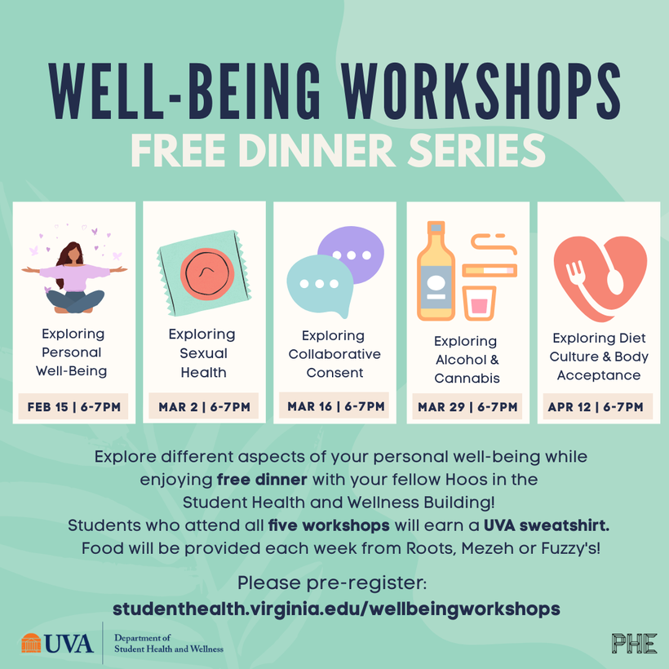

Pre-Register Here

Well-Being Workshops: Free Dinner Series
February 15th - April 12th | 6 PM - 7 PM
Student Health and Wellness
Explore different aspects of your personal well-being while enjoying free dinner with your fellow Hoos in the Student Health and Wellness Building! Students who attend all five workshops will earn a UVA sweatshirt. Food will be provided each week from Roots, Mezeh or Fuzzy's!

Library

Sneak Peak: Repositories for Sharing Data and Code for Reproducible Research
This session is held online only via Zoom on Friday, February 24th from 12:00-12:30pm ET. Registration required.
Do you have requirements to share and disseminate research results at the completion of a project or at the time of an article publication? Come for a sneak peak on how to make your research data and software FAIR and how to locate appropriate repositories to disseminate your research.
Register online here

Celebrate Black History with Children's Literature for Your Classroom
Did you know that we have a children's and young adult literature collection for our School in the Library? Check out our new Black History Month book display in the Teacher Education Children's Literature Collection in the Brown Science and Engineering Library (Clark Hall). These are perfect for elementary education! Books are available for check-out.

Upcoming Graduate Research and Writing Cafés
"Join us on Friday, February 24th from 9am-12pm in Ridley Hall 302. Hang out with us for a three hour block dedicated to free coffee, snacks, and a great workspace exclusively for graduate students, postdocs, and faculty. The three hour block is a drop-in session, so come and go as you like! Librarians will be available on-site for research consultations and writing center consultants will be available for writing support.
Held in partnership with the School of Education and Human Development's Student Affairs office and the UVA Writing Center. We hold graduate research and writing cafés once a month, check out our full schedule online.
Register online here
Check out our full Spring 2023 schedule here

