Student Newsletter

Brought to you by EHD Student Affairs, Career Services, Diversity, Equity, and Inclusion, and the Library

This will be the last newsletter of the fall 2022 semester! We hope the end of the semester goes smoothly, and that you have a restful winter break.

In this issue...
Announcements

Getting Connected (check here for some holiday fun!)

Career

Library

Office of Diversity, Equity, and Inclusion

Announcements

Get to know EHD’s new Coordinator of Online Student Success, Audrey Still!

Audrey supports the success of students enrolled in EHD’s online degree and non-degree programs. She offers advising for non-degree students, connects students to resources, answers questions about program offerings, and helps students use Canvas, Zoom, and SIS. Email Audrey at audreystill@virginia.edu!

Support for Our Students
Central Student Affairs is continuing to offer support to all students following the tragedy on grounds. More information about resources can be found here. We hope you all take care as the semester concludes.

EHD- Wide Scholarships and Awards
MONEY!!! Each year the EHD Foundation offers EHD-wide awards and scholarships to students like you to financially support their studies. Check out this webpage to learn more about the opportunities and the self-nomination process. Once you have done so, click this link to access the self-nomination form; nominations are due by January 9th! Questions? Email Blaire Cholewa at bec7b@virginia.edu

Final Exam Access to Buildings
All On Grounds EHD students will have swipe access to both Ridley and Bavaro Halls from December 3rd to December 16th at 9 p.m. to use the spaces for studying and preparation for final exams. If you have any issues with access, please email Kelly Korrington at kjk9w@virginia.edu.

Spring 2023 Canvas Student Trainings
The Education Online and Canvas Support Team is offering Canvas trainings starting in January. These sessions will introduce you to Canvas, and show you how to best utilize its features as a student of the School of Education and Human Development at UVA. Sign up here.

Requesting CVC Announcements
Do you utilize the Canvas Virtual Community (CVC) to make announcements? If so, we have streamlined the process to request a CVC announcement! Please utilize the Dean's Update submission link to request a CVC announcement.
Questions? Email Audrey Still audreystill@virginia.edu or Bern Poerio bp2uc@virginia.edu

Submissions for the 2023 Hunter Student Research Conference are open!
We encourage all undergraduate, graduate, online, and on-grounds students across UVA to consider submitting to the conference! For more information and questions, download the submission guidelines document on the HSRC website. Deadline for submissions is Tuesday, Jan. 31, 2023. Submit a proposal here!

Getting Connected

Join Ed Council at the Charlottesville Ballet!
Fill out the lottery here by Thursday, December 1st at 5pm to join Ed Council at the Charlottesville ballet on Saturday, December 3 at 2:30pm at Charlottesville High School. Lottery winners will be emailed by Friday, December 2nd!
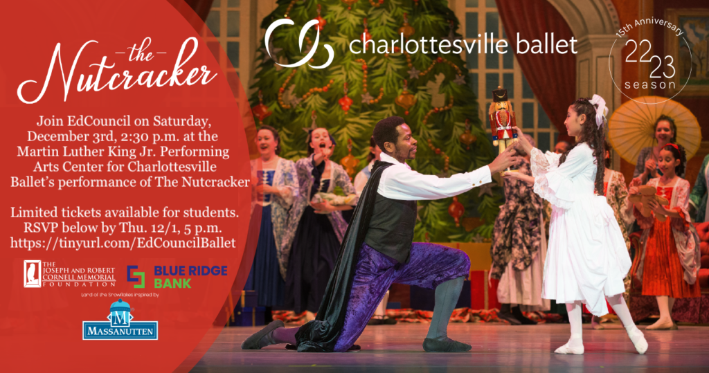

Hunter Student Research Conference: Submitting a Works in Progress Workshop
Thursday, Dec. 1 - Hunter Student Research Conference - Submitting a Works in Progress Workshop
Sometimes we want to put our work out there, but we feel like it isn't quite finished yet. A works-in-progress talk is a great way to collaboratively share your research project at any stage to further develop your research goals and obtain useful feedback throughout the process. If you want to know how to put one together, come to the HSRC Submitting a Works In Progress Workshop co-hosted with Kelly Oman and Sam Lake from PhD Plus. Bavaro 318A Register here

Wed. Nov. 30th C&I Works-in-Progress Session with Camilo Vieira
Dr. Camilo Vieira Mejia, visiting scholar, will present a C&I Works-in-Progress talk titled "Computational Thinking in Early Childhood - Cognitive Processes and Gender Stereotypes" on Wed. Nov. 30th from 11:00 to 12:00 noon in Bavaro 318-A -- lunch will be provided. Please e-mail Peter Youngs at pay2n@virginia.edu if you would like to attend.

Documentary Screening & Discussion (treats provided!), Friday Dec. 2nd at 4:30pm in Ridley 302 (the LDC)
Join fellow EHD students for a screening of the documentary, The First Year: Following Five Young Teachers. This 2001 film confronts a wide range of educational issues and relies primarily on in-classroom footage. It is real and raw and will make for some great discussion. There will be baked goods and hot chocolate! Contact dcs2ed@virginia.edu with any questions.

2022 Mary & Butch Slaughter Lecture in Kinesiology
The Department of Kinesiology presents the 2022 Mary & Butch Slaughter Lecture on Friday December 2 from 12-1pm in the Student Health & Wellness Center, Room 101B. Ross Arena, PhD, PT, professor and chair of the Department of Physical Therapy at the University of Illinois-Chicago will present "The Global Path Forward: Healthy Living for Pandemic Event Protection". All university students, faculty, and staff are invited to attend.

EHD Community and Holiday Gathering: Thursday, December 8, 2:30pm in Holloway Hall (Bavaro 116)
There will be hot beverages and delicious treats to honor the traditions of all December holidays. In addition to the treats and social time, we will be collecting non-perishable food donations to (hopefully) donate the largest contribution on behalf of the school to the Blue Ridge Food Bank. To incentive our community to donate, you will receive a raffle ticket for each non-perishable item donated. There will be some great prizes for those that participate, including UVA swag, gift cards to local spots, and a few fun experiences.
Don’t miss out on an opportunity to connect, give back, and enjoy some holiday treats! Please RSVP to help us plan for this event.

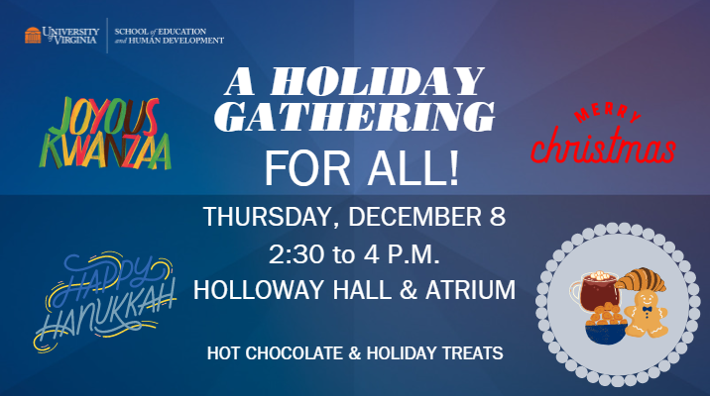

Career

UVA-EHD Live Virtual Education Resume Marathon: Thursday, 12/1/22 from 4-6:30pm
Please register here (in Handshake) to participate in these 1-on-1 (15-minute) resume critiques with Education recruiters including Arlington PS, Fairfax Co. PS, Chesterfield Co. PS, Manassas Park City Schools, Prince William Co. PS, Southern Teachers Agency (Independent School Recruiting Agency) and more!
Target your resume for EHD-related careers, prepare for Ed Expo, and connect with education recruiters through these Virtual 1-on-1 (15-minute) resume critiques with education recruiters from PK-12 divisions and education organizations. More details can be found here. Join the Zoom meeting any time during the event (4pm-6:30pm), remain in the "waiting room" until you are assigned to meet 1-on-1 with an education recruiter. You will receive a 15-minute individual resume critique, and may ask any "quick" questions about recruiting. This is a wonderful way to meet and connect with education recruiters early!

Hoo2Hoo Network: Job Opportunity for Students
The Learning Design and Teaching Innovation team is looking for a Peer Technology and Innovation Mentor for our Hoo2Hoo Network. We are looking for someone who is eager to teach various technology based skills to the UVA EHD community. In this role, you will work in an environment where diverse and innovative perspectives are strongly encouraged and valued. As a peer mentor you will gain experience in the instructional design process as well as facilitate a variety of technology based instructional workshops in collaboration with your peers. This program provides opportunities for student leadership as well as equip students with both the knowledge base and skill set to be competitive within their future careers and expand on their extracurricular interests. This is a part-time position for UVA students, and it will run from January 2023-May 2023. Apply here.

Get Resume Ready using VMock!
Get your resume ready and join us at the 12/1 Education Resume Marathon! Need to prepare your resume in advance? Try VMock to receive instant feedback on your resume: VMock is a 24-7 online resume review tool available to you, that leverages data science, machine learning, and natural language processing to provide instant personalized feedback. When you upload your resume, the platform assesses components such as action verbs, format, and how well the 5 core competencies (analytical, communication, leadership, teamwork, and initiative) are reflected in your document. Then come and have an education recruiter provide professional advice to make your resume stand out for your job search at our 12/1 Ed Resume Marathon. Learn more here!

Fulbright Taiwan Announces 2 Scholarship Programs for English Teaching and English Teacher Trainer Programs
Mindy Lin (mlin@fulbright.org.tw) from Fulbright Taiwan announce two great scholarships provided by their foundation for students graduating in the spring or summer of 2023. They are looking for enthusiastic applicants in the English Teaching and Education field who have experience in real-life classrooms. They offer a chance to live in Taiwan and experience cultural exchange and provide the opportunity to bring your creativity to the students while learning from Taiwanese educators.

1) English Teaching Flagship (ETF) Scholarship Program: We are offering 77 grantees a full scholarship of 11 months in Taiwan with a round-trip flight ticket between the US and Taiwan. The program requires 16-20 hours of co-teaching per week in the local elementary or junior high schools or assisting in the internationalization of the universities. Please click here for more information.
2) English Teacher Trainer (TEFL Advisor) Program: We have given this scholarship to 12 grantees during the year 2022-23. We provide 11 months of grant with a round trip flight ticket between the US and Taiwan. The grantees are invited to train the Fulbright English Teaching Assistants, Fellows, Local Taiwanese English Teachers, and international students in universities who are doing part-time teaching assistants in primary schools.
Application deadline is February 20, 2023:
Please click here for more information. Find out more and how to apply here.

Library

Last Graduate Café of the Semester!
This Friday, December 2nd, we’ll be holding our final fall Graduate Research & Writing Café in Brown 133 (the classroom in Brown Library) from 9:30am-12:30pm. Come by for free coffee, hot chocolate, and bagels, and enjoy a great workspace exclusively for graduate students. The three hour block is a drop-in session, so come and go as you like! Librarians will be available on-site for research consultations. Held in partnership with the School of Education and Human Development's Student Affairs office and the UVA Writing Center. Graduate students from all departments are welcome. Register here.

Office of Diversity, Equity, and Inclusion

Common Read Book Groups
What chapter are you on in the Common Read book, Life Isn’t Binary: On Being Both, Beyond, and In Between? The Office of Diversity, Equity, and Inclusion and Diversity Action Committee are piloting book groups this year and this effort will ramp up in the Spring semester. Complete this survey if you are still looking for a book group or have a book group that is open to others.
Book group survey - https://virginia.az1.qualtrics.com/jfe/form/SV_doRIfEZMMRxvk9M

ODEI Newsletter
Thank you to everyone who joined us yesterday for the November Collective Learning Series engage session around affordable housing. The Collective Learning Series examines issues that impact education in a monthly read (week 1), watch/listen (week 2), reflect (week 3), and engage (week 4) format. Although this was the last Collective Learning Series for the semester, we look forward to connecting around Collective Learning Series in the spring.

