Student Newsletter

Brought to you by EHD Student Affairs, Career Services, Diversity, Equity, and Inclusion, and the Library

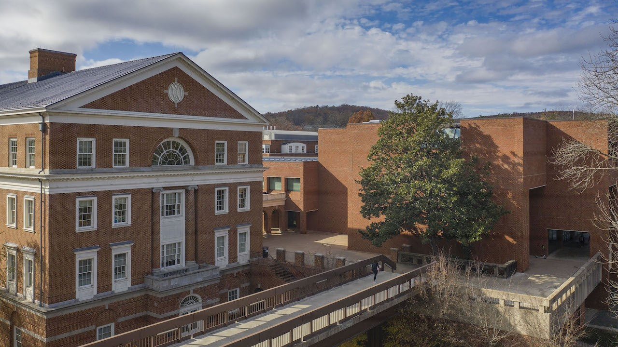

In this issue...

Career
Announcements
Office of Diversity, Equity, and Inclusion
Getting Connected
Library

Career

Meet Hilary Kerner, EHD’s Director of Career Services!

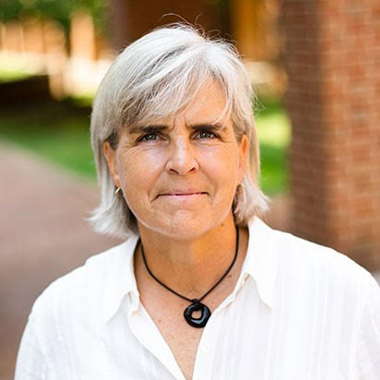
Hilary helps connect education and human development-related employers and students, and assists EHD students in launching their careers. Email Hilary at kerner@virginia.edu or click this link to schedule an appointment with her!

EDH Career Corner
It would be scary if you never visited the EDH Career Corner in Canvas!
There you can find the latest UVA EHD-centric job & internship opportunities from EHD faculty, alumni and friends. You can also find how to set up appointments for EHD one-on-one Career Assistance Available during Fall 2022 with your UVA-EHD Career Advisor, Hilary Kerner (Tuesdays 12-2pm virtual or Wednesdays 3-5pm either virtual or in-person). Please select a 30-minute appointment slot here.
Or, email kerner@virginia.edu to request a time to meet between 12-4pm, M-Th.
Either in-person or virtual appointments are available on Wednesdays and Thursdays.

Virtual Education Resume Marathon
Get Ready for our Virtual Education Resume Marathon (on 12/1/22) with VMock on December 1, 2022.
Need to update your resume and receive instant feedback on your resume to prepare? Try VMock, a 24-7 online resume review tool available to you, that leverages data science, machine learning, and natural language processing to provide instant personalized feedback. When you upload your resume, the platform assesses components such as action verbs, format, and how well the 5 core competencies (analytical, communication, leadership, teamwork, and initiative) are reflected in your document. Try VMock here!

Announcements

Join the Diversifying Scholarship Conference Committee
Diversifying Scholarship is a graduate student-run conference now on its sixth annual cycle. The conference is dedicated to uplifting research focused on diversity, inclusivity, and reducing inequality and bias. We work to bring together scholars at all levels from institutions across the country. Our last two conferences took place virtually, and were very successful! Check out our website for more info.
Diversifying Scholarship 2023 will be a virtual Zoom meeting on 4/21/23! We have an excellent keynote speaker (Dr. Enrique Neblett, Professor at the University of Michigan).
Committee members are involved in advertising, program development, abstract review, day-of conference facilitation, presentation review, monitoring email, maintaining social media, and editing/updating the website. You're also welcome to submit an abstract to present on your own data, if this is something that you're interested in! We meet on Zoom about once per month to check in and delegate tasks.
In addition to these virtual meetings, we will also have a fun fall/winter get together to get to know each other and interact outside of our Zoom squares! There has also traditionally been a celebration after the conference at one of our homes.
~Special call~ for first, second, and third-year grad students:

Flu Shots Available at UVA Bookstore
One of the best kept secrets at UVA is there is a pharmacy over at the bookstore across the street. Located in the back by the greeting cards, the pharmacy is open M-F 9a to 5:30p. Additionally, they also can administer common immunizations i.e. flu, shingles etc.
You do have to make an appt, you can call either 3-5509 or 3-5518. If you work at UVA, have UVA health insurance and/or are treated here, your info in probably already in patient management system. There is a little bit of paper work, but nothing oppressive.

Office of Diversity, Equity, and Inclusion

SEEDSforChange Conference Scholarship

Apply now!

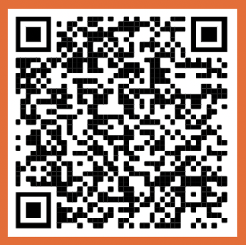

Opportunity for a $250 scholarship to support SEHD students pursuing equity-related conference participation. Requirements include: UVA SEHD undergraduate/graduate student presenting equity-related research and/or attending an equity-related conference between Sept. 2022 - Feb. 2023
Fill out the simple application, due Nov. 4. Applications are reviewed by an external faculty committee. APPLY HERE.

Collective Learning Series
Half of Americans report that the availability of affordable housing in their local community is a major problem, but displacement of locals persists, especially in college towns. Please Join the Office of Diversity, Equity, and Inclusion for November’s Collective Learning Series on Affordable Housing to examine the issues nationally, regionally, and locally. The engage session will be hybrid in Holloway Hall at 2pm on November 29th. Click this link to access materials, RSVP for in-person attendance, or register for zoom participation.

Getting Connected

Transition to Adulthood and Disability Talk
Join us virtually for the next talk in our Blue Ridge LEND Lunch & Learn series on Friday, November 4th on the topic of transition to adulthood for individuals with disabilities. This talk will feature a brief presentation and a series of questions with Brian Carr, who has lived experience with cerebral palsy. Register here!

EHD First-Generation Student Celebration
First-generation student week is November 7-11! Join EHD Student Affairs at an event for our first-generation students on Monday, November 7th, from 1-2:30pm. Stop by our table to grab some swag and make a goodie bag to-go! RSVP here.

Cooper Speaker Series- Keisha L. Green
Keisha L. Green, Associate Professor of Teacher Education and Curriculum Studies in the University of Massachusetts Amherst College of Education, will present a Cooper lecture on Wed. Nov. 9th in 302 Ridley Hall from 11:00 am to 12:15 pm. The title of Dr. Green's lecture is "Still 'Teaching to Transgress' and Disrupting to Sustain: Critical Pedagogies and Culturally Sustaining Practices in Teacher Education."
This lecture is sponsored by the Cooper Speaker Series and it is open to all UVA faculty, postdoctoral researchers, students, and staff. You do not need to RSVP in order to attend. If you have any questions, please e-mail Peter Youngs at pay2n@virginia.edu.

Session for EHD Ph.D. Students on Dissertation Proposals/Dissertations
Natalia Palacios (UVA faculty in Ed Psychology/Applied Developmental Science) and Peter Youngs (UVA faculty in Curriculum and Instruction) are going to host a session for EHD PhD students titled “Developing Dissertation Proposals and Writing Dissertations” on Tuesday, November 15th from 3:00 to 4:00 pm in Ridley 200. The session will focus on such topics as “What is candidacy?,” the role of the comprehensive exam, three-manuscript dissertations vs. book-length dissertations, creating a dissertation committee, timelines, and other topics/questions. You don’t need to RSVP in order to attend-- If you have any questions, please contact Natalia at nap5s@virginia.edu or Peter at pay2n@virginia.edu.

Wed. Nov. 16th C&I Works-in-Progress Presentation
Helen Min, 4th-year PhD student in Curriculum and Instruction, will present a C&I works-in-progress talk titled "When Traumas Intersect: A Mixed Methods Examination of Teachers’ Adverse Childhood Experiences and their Professional Quality of Life. This session will take place on Wed. Nov. 16th from 11:00 to 12:00 noon in Bavaro 318-A -- if you are interested in attending, please e-mail Peter Youngs at pay2n@virginia.edu.

Library

Graduate Program and Café: 11/9
Join us for our workshop and cafe series! From 11:30am-12:15pm we'll cover library support options for graduate students: book delivery, ILL, New York Times access, and more!
Then hang out with us for free coffee, snacks, and a great workspace exclusively for graduate students. The two and a half hour block is a drop-in session, so come and go as you like! Librarians will be available on-site for research consultations and writing consultants from the UVA Writing Center are available for help with your papers. RSVP here!

Abbott Elementary Pop-Up Library
What books would be on our favorite Abbott Elementary teacher's PD bookshelves? Join us in Holloway Hall (Bavaro 116) for the Abbott Elementary Pop-Up Library! We've gathered a selection of books that Janine, Barbara, Gregory, Jacob, and Melissa would love. Books will be available for check-out on the spot. We'll be in Holloway from 12pm-3pm.
We're hosting this pop-up during our graduate cafe! If you are a graduate student, join us for coffee and snacks. Information here.

