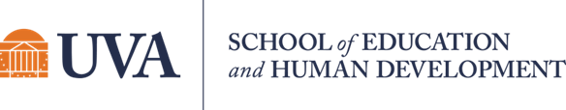

Student Newsletter

Brought to you by EHD Student Affairs, Career Services, Diversity, Equity, and Inclusion, and the Library

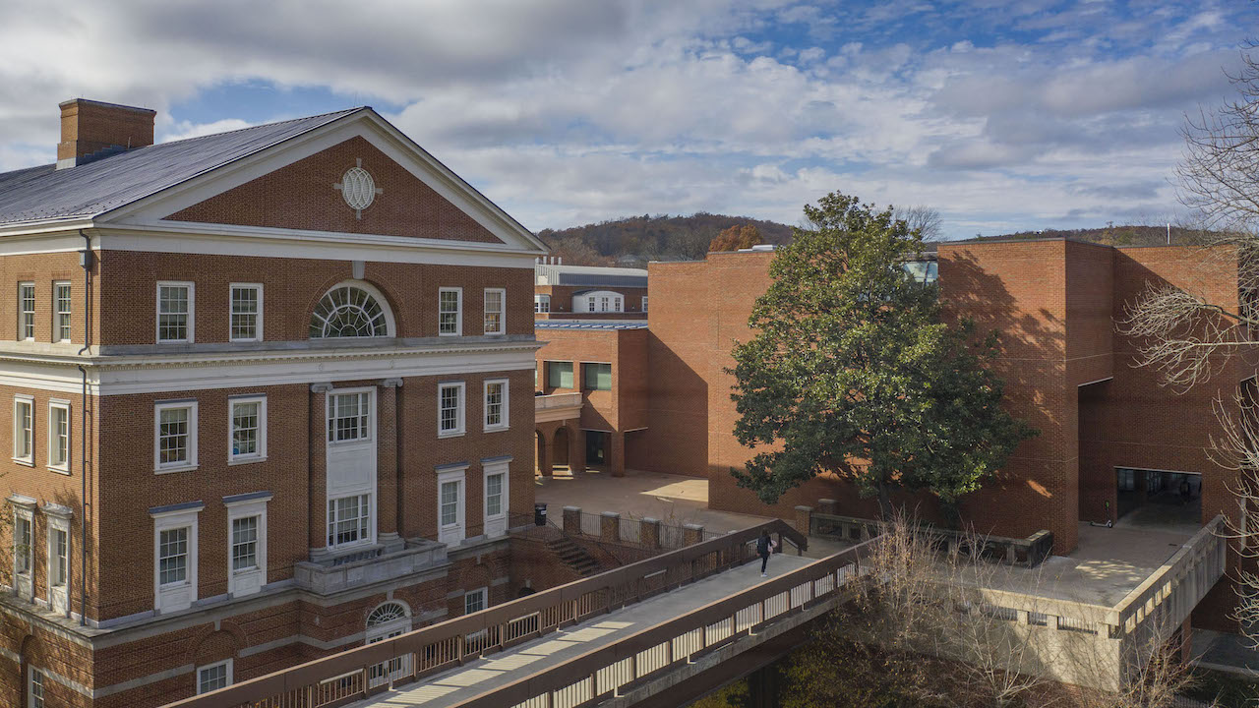
In this issue...

Office of Diversity, Equity, and Inclusion
Getting Connected
Announcements
Career

Office of Diversity, Equity, and Inclusion

Get to know ODEI!

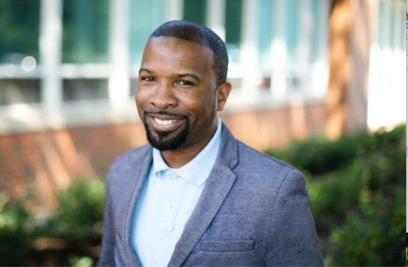 | 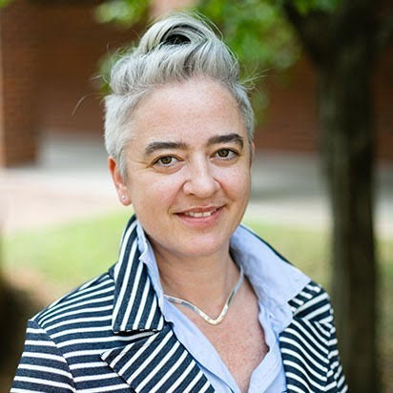 | 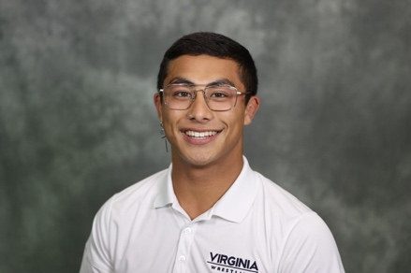 | 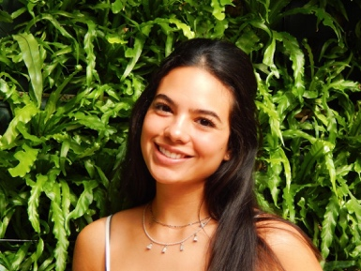
LaRon Scott (he/him), EdD, is the new Associate Dean of Diversity, Equity, and Inclusion, and Associate Professor in Special Education. His research focuses on the intersections of race and gender in attracting, preparing, and retaining special education teachers, and postsecondary transition experiences for youth of color with an intellectual and developmental disability (IDD). | Mary Margaret Hughes (she/her) is graduate intern in the Office of DEI. She is a 4th year PhD candidate in special education whose research examines intersectional marginalization of ability and co-founder of Out and Allied Educators. | Alexander Cruz (He/Him) is a current graduate student in the School of Education and Human Development studying Student Affairs Practices in Higher Education. He works in the Office of Diversity Equity and Inclusion as our Graduate Intern and is the founder of Athletes for Equality here at UVA. | April Canahuati (she/her)  Is a current 4th year student, seeking a Bachelor's degree in Elementary Education with a certification in ESL. She is creative and goal-oriented, and cares about the future of education!

Hoos ODEI Corner
Every month, the Office of Diversity, Equity, and Inclusion culls together materials around relevant issues of DEI for you to read (week 1), watch/listen to (week 2), reflect upon (week 3), and engage as a community (week 4). October’s Collective Learning Series examines this issue of cultural appropriation. The materials are live now and the hybrid engage event is October 27th at 2pm in Ridley 302. Follow this link to access the materials, and RSVP for the in-person session or register for the virtual engage event on the 27th.
What chapter are you on in the Common Read book, Life Isn’t Binary: On Being Both, Beyond, and In Between? Have you gotten a book group together yet? If you indicated interest in joining a book group or organizing a book group, you’ll be hearing from us soon. Complete this survey, if you are still looking for a book group or want to apply for your book group to get micro grant funding for your get togethers.
The next Beyond the Common Read event is coming up on October19th at noon and will feature the expertise of our own Tish Jennings to share with us ways in which we can be gentler with each other. Join us in person (Holloway Hall) or online for Beyond the Common Read: Everyday Trauma Sensitive Approaches. RSVP and register here.

Writing Impactful Public Comment Statements
Out & Allied Educators will be hosting a workshop on how to write impactful public comment statements on October 6th from 10:00-11:30am. EHD's very own Dr. Julia Taylor will provide those in attendance with step-by-step tips for drafting effective public comments and offer best practices and resources. Recent LGBTQ+ inclusion and equity matters are recent communication that will be shared, as well as addressing areas of DEI to improve the overall student experience. We look forward to having you join us. Please RSVP here

Let Your Voice Be Heard
Did you know that you have an opportunity to weigh in on VDOE’s new policies regarding transgender students? Public comments opened September 26th and will remain open for 30 days. Please feel free to look over the new policies and interact with the discussions happening around the Charlottesville community and use your voice.

Bolivar Network Scholarship
The Bolívar Network is awarding four $750 Book Scholarships to three undergraduate and one graduate Latinx student who demonstrate leadership, academic achievement, service, vision, and a dedication to the Latinx/Latin American/Hispanic community. This is the Bolívar Network’s first time offering a graduate school scholarship! The deadline to submit applications is Saturday, October 15, 2022, by 11:59 pm EST.

Getting Connected

The Graduate Application Process Workshop
The Graduate Application Process workshop's main goal is to help students who are interested in applying to a Master's or Ph.D. level program and who want to learn more about the application process. This will connect both undergraduate and graduate students to current graduate students who are already in a Master’s or Ph.D. program. Students will be broken up into small groups with current graduate students and will discuss the following themes: financial considerations, CV and resume preparation, organizing your grad school search, and how to reach out to faculty. The event is designed with first
generation students in mind but open to all students.

Select your preference of in person or Zoom. RSVP here.
In person event:
Wednesday, October 12th
12:00 - 1:30 PM EST
3rd Floor, Ridley Hall
Zoom event:
Wednesday, October 19th
6 - 7:30 PM EST
Zoom
*Please note the content is the same for each event!

First Generation Graduate Student Coalition Fall Social 2022
Thursday, October 13th from 3-5 PM outside in Garden I (behind the Lawn across from the church - map here)
Join the First-Generation Graduate Student Coalition (FGSC) for our Fall Social to reconnect with other graduate students and build community in the new academic year. We’ll have light refreshments, snacks, and exciting lawn games! Drop by to say ‘hi’ and support first-generation college students who are pursuing their graduate degrees at UVA. We look forward to meeting you!
*To RSVP for the social, please follow this link. Also, to stay up to date with the FGSC and our latest happenings, be sure to follow us on Instagram.

Announcements

Kinesiology Works-In-Progress Presentation
Professor Martin Block will present "Using a Social Justice Framework to Promote the Inclusion of Children with Disabilities in Physical Activity" on Friday October 7 from 12:00-1:00pm in 101B Student Health & Wellness Center. This lecture is open to all UVA faculty, postdoctoral researchers, students, and staff -- you do not need to RSVP to attend. If you have any questions, please contact Jay Hertel at jnh7g@virginia.edu

Genetics of Neurodevelopmental Disorders
You are invited to join us virtually at our upcoming Blue Ridge LEND Lunch & Learn on Friday, October 14th as we hear from Mackenzie Trapp, MS, LCGC on the genetics of neurodevelopmental disorders. She is a board-certified genetic counselor at the university, and her introduction will be tailored to a wide audience. RSVP here.

Navigating Life Workshop Series: Financial Literacy
Join Ed Council Equity Committee on October 14th for a session on financial literacy with local financial advisors!
Friday, October 14th – 9:30 AM-11:30 AM, Holloway Hall, click here to sign up!

Digital Research Dissemination Workshop
Wednesday, Oct. 19, 3:30pm
Digital Research Dissemination Workshop: We live in a digital world, and it can be hard to captivate an audience with your research with so much out there. The digital research dissemination workshop is going to teach you how to stand out from the online crowd and get more eyes on your hard work. Bavaro 318A and Zoom. Register here.

Finding Mental Health Care Providers in the Community
The workshop will be held in the Student Health and Wellness Building (550 Brandon Ave) in the Multi-Purpose Room (first floor, directly to the right of the main front entrance.) Visitor parking is available!
o If you are a current student seeking care in your community (in Charlottesville or across the U.S.) or if you are graduating, this workshop is for you!
o We’ll discuss insurance benefits and help students learn how to identify and connect with a provider who’s right for them.
o Free cookies and fidget toy giveaways!
Please email capscaremanagers@virginia.edu with any questions

Volunteers Needed: Youth-Nex Conference on Youth Voice & Agency
Youth-Nex is hosting their 8th conference on October 25th & 26th! Although registration is closed, they are seeking students who still want to attend parts of the conference. We need student volunteers to help run panel sessions and host presenters/attendees! We will schedule around your classes/commitments and based on your interests. Check out the conference website for more and email Youth-Nex@virginia.edu if you're interested!

VEST Education Research Lectureship Fall Series
These are the 3 VEST Education Research Lectureship Series
Here are the links on our events page too:
10/7: Epochs of School Segregation: Racial Inequality from 1968 to 2020
10/21: Youth-Adult Relationships Across Contexts and Time: Understanding trajectories and roles of adolescents supportive relationships with important adults
11/11: Teacher Candidate Preparation and Teacher Outcomes

Career
Healthcare Careers Week: October 10-14
Want to make an impact? Join the UVA Career Center and Pre-Health Advising in exploring which Healthcare career is right for you! During this week you will be able to explore both clinical and non-clinical Healthcare careers, learn from alumni, and connect with employers for internships and jobs.
Tuesday, October 11: Healthcare Career Panel + Networking Event (Non-Clinical Focus)
Register here!
Wednesday, October 12: Healthcare Career Week Drop-ins with UVA Career Center Counselors and Pre-Health Advisors
Register here!
Centers for Medicare and Medicaid Services (CMS) Alumni Drop-Ins
Pre-register here!
Health Careers Shuffle (Clinical Focus)
Register here!
Thursday, October 13: Biotech, Science, & Healthcare Career Fair
Register here!
Friday, October 14: Careers Related to Counseling (Sponsored by the School of Education and Human Development)
Register here!

EHD Career 1 on 1s Available
Did you know that UVA-EHD part-time, internship and full-time job search assistance is available? For help with resumes/CVs, cover letters, personal statements for graduate applications or finding opportunities, you can set up a one-on-one virtual appointment with your UVA EHD Career Advisor, Hilary Kerner (Tuesdays 12-2pm or Wednesdays 3-5pm) Select a 30-minute appointment slot here.
Or, email kerner@virginia.edu to request a time to chat!

UVA PhD+ Career Resources
Do you know about UVA PHD+? They have some pertinent career events approaching, particularly if you have any interest in consulting careers: You can find them here.

Teaching Career Abroad Panel
Registration is open for: Teaching Careers Abroad panel, Great Hall in Garrett Hall, Tuesday, November 1, 2022, 5:30-7pm, in person event. Interested in teaching abroad after graduation? Attend this panel to hear from and network with experts who have taught outside of the U.S. including AMISA who also places students in International Schools in the Americas. This event is part of Global Week at UVA and will be presented by Batten Career Services, the School of Education and Human Development (EHD) Career Services, and the Central Career Services EYD Community. Panelists include, Derek Rhoads, Executive Director of American International Schools in the US (AMISA) and Carizma Brown, AMISA. Panelists will be updated as the event nears. Please register here (in Handshake):

International Students & Employment Options in the U.S.
Mark Rhoads, an Immigration Attorney from Richmond and frequent speaker at UVA and NACE, along with UVA’s Sr. International Advisor Richard Tanson, will present on ways for international students to learn about various ways to pursue work in the US during summer breaks and post-graduation. Immigration attorney Mark Rhoads will discuss CPT, OPT, H-1B visas, other specialty visas, important timelines, and resources for both students and employers. Bring your questions and gain expert advice.
Register here for Zoom Webinar link.

