Student Newsletter

Brought to you by EHD Student Affairs, Career Services, Diversity, Equity, and Inclusion, and the Library

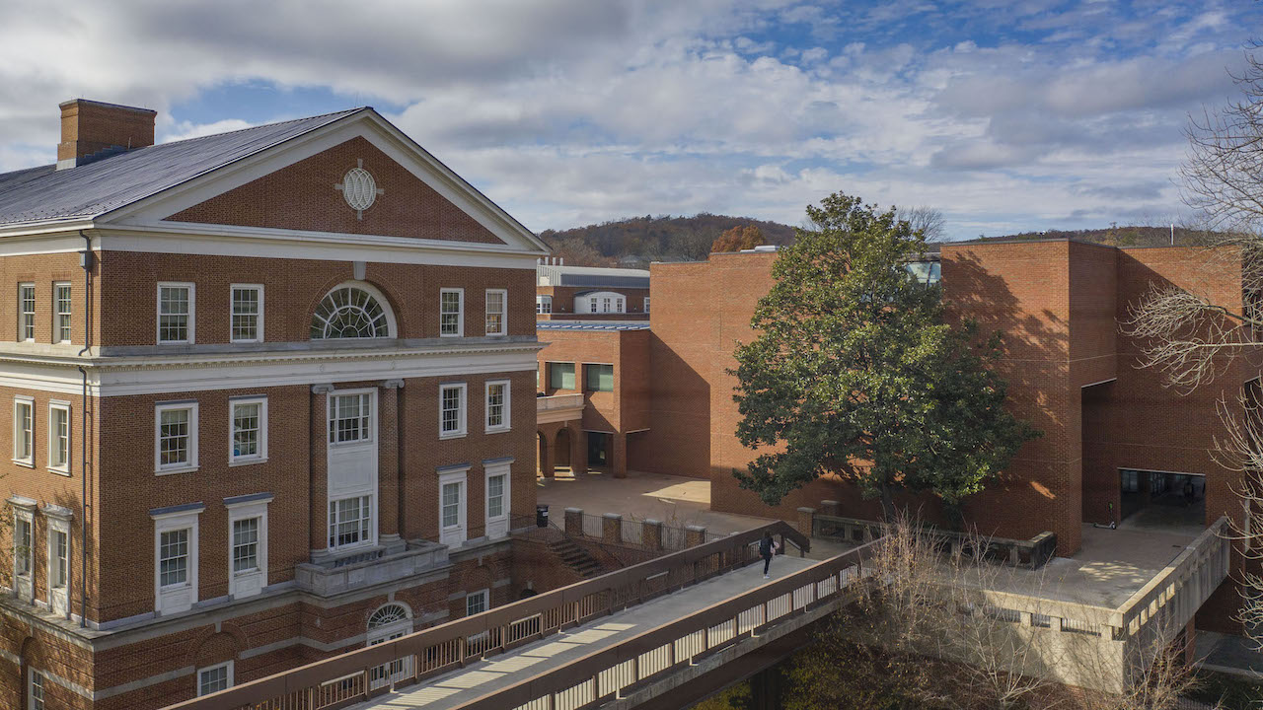

In this issue...

Getting Connected

Announcements

Career

Office of Diversity, Equity, and Inclusion

Getting Connected

EHD Student Affairs Partnering with IM-REC
EHD Student Affairs is partnering with IM-REX to offer TWO fitness classes:
SPIN: Friday, September 23, 10am in AFC Cycle Studio
YOGA: Friday, September 30, 3pm in AFC MP4 Studio
RSVP here!

Share a Meal with Dean Rowley
EHD Student Affairs is excited to announce the “Share a Meal” with Dean Rowley program. We have partnered with the Deans Office to plan meals for undergraduate, doctoral, and master’s students (in-person) as well as an online-student only event. Sign up to be entered into the lottery here!

Down Syndrome & Parent Perspectives
Please join us for our next Blue Ridge LEND Lunch & Learn talk, "Down Syndrome and Parent Perspective," presented by a panel of parents of children with Down Syndrome, and led by Dr. Valentina Intagliata, MD.
Friday, September 23rd, 12-1 PM , Zoom.

Graduate and Professional Student Convocation and Resource Fair
The Graduate and Professional Student Council invites you to a welcome convocation for all graduate and professional students on Tuesday, September 27 from 1-3 PM in the McIntire Amphitheatre on Central Grounds. Following welcome remarks from Executive Vice President and Provost, Ian Baucom, and Chair of the UVA Graduate Professional Student Council, Annie Somerville, there will be a variety of activities.

Announcements

EHD Student Affairs Pulse Survey
Check your email for a Pulse Survey from Director of Student Affairs, Jessica Livingston! This survey is to gauge students' well-being, as well as determine immediate needs to inform ongoing design and facilitation of support and resources.

EHD Student Affairs
EHD Student Affairs is a confidential space for students! Have a question, need a resource, or want to report a concern? Reach out to EHD-StudentAffairs@virginia.edu and we will work with you!

Fall 2022 Semester CAPS Groups
CAPS will be offering several groups throughout the fall semester, including: Interpersonal Process Group, Skills Development, Support Groups, and Spaces for Connection. More information here!

Madison House Volunteering Opportunity- Athletics
Through Athletics, volunteers can teach kids the fundamentals and basic skills of a variety of sports, such as soccer, lacrosse, swimming, baseball, running, and more. Experience in the sport is preferred but not necessary, and no coaching experience is needed. The emphasis is placed on learning, teamwork, and having fun.
Those interested can use this link to see more information about the specific programs we offer and use this form to connect with whichever ones they are interested in joining.

Laundry and Printing Grants
Student Council is excited to announce the Cavalier Advantage Grant Program! This program will distribute $5 grants to students to use on laundry, printing, or food at the on-grounds convenience stores. You can apply for a grant here. Please note that we cannot give any one student more than $25 per semester so as not to impact financial aid. Additionally, it may take up to two weeks for this money to enter your CavAdvantage account.

Designed for Online Podcast - New Episode
Welcome back to a new season of Designed for Online! As many courses are still online (whether or not due to the pandemic of COVID - 19), the topic of creating meaningful relationships from a distance can be very informative for professors and students.
Join us in this episode as Ashley Caudill Interviews UVA instructor, Ottilie Austin to understand her experience and knowledge of what is necessary to create a positive and meaningful online learning environment to better connect with her students.
Spotify Link.

Next Steps Fund
The Next Steps Fund is a partnership between Student Council and CAPS which provides full subsidies for 4 sessions with a mental health care provider in the Charlottesville community outside of CAPS, decreasing the financial burden of accessing ongoing treatment. If you are interested in using the fund to support your treatment, visit this link and follow the steps listed.

Youth-Nex Talk: A Future for Black Youth’s Stories in Schools
You are invited to an in-person Youth-Nex talk on Friday September 30th at 11 AM in Holloway Hall. Dr. Stephanie Toliver from the University of Colorado Boulder will give a talk on “Endarkened Storywork, or A Future for Black Youth’s Stories in Schools. Coffee and bagels will be provided! Grad students interested in meeting with the speaker should RSVP to Youth-Nex@virginia.edu.
More information can be found here.

Active Attacker Prevention, Response, and Notification Training
October 11th, 12-1pm Newcomb Hall South Meeting Room
In this 60-minute training, the Department of Safety & Security will discuss what University Threat Assessment, Emergency Management, and the Police Department are doing to prevent and if needed respond to and notify the UVA community of an active attacker event. Participants will learn about Emergency Notifications, how to report concerning behavior, and easy-to-remember options for people who are faced with a violent situation. For more information, contact Rachel Slotter (Office of Emergency Management) at ras5zm@virginia.edu. Please register for the training here.

EdCouncil Equity Committee “Navigating Life” Financial Literacy Workshop
October 14th at 9:30am
Join us in Holloway Hall for a workshop on financial literacy hosted by EdCouncil and First-Generation Graduate Student Coalition. We are hosting financial planner speakers from the surrounding community to talk about and provide resources for topics such as high yield savings accounts, credit, 401K, investing/saving for the future, etc. Be on the lookout for more information and event registration to come!

Nominate a student or alum for OCM features!
Do you know a student or alum who is doing great work and representing EHD well? Nominate them to be featured by the Office of Communications and Marketing! OCM is always looking for students and alumni to feature on the EHD website, on social media, and in marketing materials. Nominations can be submitted anytime using the form below. Students and alumni can fill out the form themselves, or faculty and staff can nominate someone and OCM will follow up with them. Questions? Contact Laura Hoxworth.
Submit nomination here.

Career

EHD Career 1 on 1s Available
Did you know that UVA-EHD part-time, internship and full-time job search assistance is available? For help with resumes/CVs, cover letters, personal statements for graduate applications or finding opportunities, you can set up a one-on-one virtual appointment with your UVA EHD Career Advisor, Hilary Kerner (Tuesdays 12-2pm or Wednesdays 3-5pm) Select a 30-minute appointment slot here.
Or, email kerner@virginia.edu to request a time to chat!

Teacher Coaching/RA Opportunity for Graduate Students
Are you interested in gaining experience coaching and offering support to educators while working on an exciting research project? We are looking for qualified graduate students to join our team. We are looking for a small team of coaches to learn more about the intervention and offer support to participating teachers during bi-weekly meetings and weekly check-ins for about 4 hours weekly. This could be a paid position for work study students and/or also be completed for research credit. If you are interested in applying for this position please complete this google form application.
If you have any questions, feel free to reach out to Marissa Bivona mab2dx@virginia.edu or Hannah Rollins hmr4fn@virginia.edu with the email header "Banking Time Coach Position.
For more information on Banking Time click here.
Post-Doctoral Job Search Process
Julie Cohen and Peter Youngs will hold a session via Zoom on the post-doctorate job search process on Wed. Sept. 28th from 3:00 to 4:00/4:15 pm. We will focus on applying for assistant professor positions as well as positions with research organizations, non-profits, school districts, etc. In particular, we will go over the following: identifying positions/searches; developing a cover letter, diversity statement, research statement, and teaching statement; preparing writing samples; identifying references; doing practice job talks; initial Zoom interviews; campus visits; and negotiating salary and other issues. If you would like to attend this session, please e-mail Peter Youngs at pay2n@virginia.edu for the Zoom link.

Save the Date: Teaching Careers Abroad Panel
Tuesday, November 1, 2022, 5:30-7pm, in person event. This is part of Global Careers Week and will be presented by Batten Career Services, the School of Education and Human Development Career Services, and the Central Career Services EYD Community.

EHD International Students: Opportunity to learn about Employment Options in the U.S.
Join Mark Rhoads, Immigration Attorney, and UVA’s International Advisor Richard Tanson, to learn about various ways to pursue work in the US during summer breaks and post-graduation. Rhoads will discuss CPT, OPT, H-1B visas, other specialty visas, important timelines, and resources for both students and employers. Bring your questions and gain expert advice. Watch this space for the link for October 12, 2022.
Register here!

EduTutorVA
EduTutorVA continues to expand its work with school districts and is recruiting more college tutors. Earn $1,700-$2,500/school year with flexible days & hours and build your resume! Sign up here: bit.ly/3eKtvpF For questions, please contact: Roberto A. Pamas rpamas@gmu.edu

Office of Diversity, Equity, and Inclusion

Collective Learning Series: Multilingualism
Multilingualism is an experience that shapes our brains for a lifetime in areas such as attention, empathy, reading, and engagement in an increasingly multicultural world. Please join us 9/27 for the September Collective Learning Series engage session where we will hear from multilingual panelists on their experiences. You can join us in person in Holloway Hall or virtually on zoom at 2pm September 27th. You can access the materials, RSVP, and register for the zoom here.

Teaching Outside the Binary with Mx. Ace Schwarz
Co-sponsored by Office of Diversity, Equity, and Inclusion and Out and Allied Educators, this virtual event will feature the groundbreaking pedagogical and advocacy strategies of GLSEN’s 2019 Teacher of the Year for addressing issues of gender and sexuality binaries in the classroom. Please join us on October 4th from 4:30-5:30. Find out more and register here.

